**Multi-Magnification Surface Roughness Prediction Using SEM Imagery and Deep Convolutional Neural Network**

Md. Ashikur Rahman Khan1,*, Md. Shariar Kabir Asif1, Ishtiaq Ahammad1

|  |  |
| --- | --- |
| |  | | --- | |  | |

1Department of Information and Communication Engineering, Noakhali Science and Technology University, Noakhali 3814, Bangladesh, [1](mailto:1)[ashik@nstu.edu.bd](mailto:ashik@nstu.edu.bd), [1asif1113@student.nstu.edu.bd](mailto:1asif1113@student.nstu.edu.bd), 1ishtiaq@nstu.edu.bd

*Corresponding Author, E-mail: ashik@nstu.edu.bd

**Abstract**

In recent years, the advent of Convolutional Neural Networks (CNNs) has opened up new avenues for advancing Surface Roughness (SR) prediction methodologies, particularly through the analysis of Scanning Electron Microscope (SEM) images. However, notable gaps existed in the literature regarding the application of CNNs to SEM images for SR prediction. This research addresses these existing gaps by employing a CNN to analyze SEM images for SR prediction, with a particular focus on comparative analysis of different magnification levels. Three distinct datasets, magnified at 150X, 250X, and 500X, were utilized, comprising 2097, 2103, and 2102 images, respectively. These images undergo preprocessing techniques to enhance the CNN model's ability to generalize to new images. Subsequently, a sequential CNN model, comprising 27 layers including convolutional, max pooling, batch normalization, flatten, and fully connected dense layers, is developed and trained on the datasets. The study provides detailed comparative analyses of accuracy, precision, recall, and F1-score across magnification levels. Results indicate that the dataset magnified at 500X consistently outperforms the others, exhibiting superior accuracy (75.7%), precision (0.65), recall (0.72), and F1-score (0.72). Higher magnification levels provide finer details and more explicit images, enabling the model to discern subtle features with increased accuracy. Additionally, the 500X dataset exhibits a better balance between minimizing false positives and false negatives, making it more suitable for real-world applications requiring detailed analysis of microscopic structures. These findings underscore the importance of selecting appropriate magnification levels in SEM imaging for accurate SR prediction.

**Keywords:** Surface Roughness; Surface Roughness Prediction; Scanning Electron Microscope (SEM); Convolutional Neural Network (CNN); Magnified SEM Images

**1. Introduction**

**1.1 Introduction**

In contemporary research across various fields, surface roughness (SR) stands as a pivotal parameter, offering invaluable insights into surface topography and texture [1]. The applications of SR measurements span a multitude of scientific and engineering domains, each harnessing its potential to optimize materials, explore biological systems, manufacture microdevices, and elevate product quality. Notably, in the realm of engineering, SR assumes critical significance in tribology, where the study of friction, lubrication, and wear demands meticulous attention [2]. Moreover, materials science and mechanical design are deeply intertwined with SR considerations, as engineers factor in SR when selecting materials for components that interact with other surfaces, such as bearings and gears. In the manufacturing landscape, SR plays a pivotal role in ensuring the overall quality and functionality of end products [3].

The aerospace industry places paramount importance on SR, as it directly influences aerodynamic performance, durability, and safety in aircraft and spacecraft. SR measurements are crucial in ensuring that surfaces adhere to stringent specifications, thereby optimizing performance and ensuring that safety standards are met [4]. Furthermore, the structural integrity of aerospace materials relies on SR assessments, as minute cracks and defects originating at the surface can lead to catastrophic failures over time. Hence, SR measurements serve as a vigilant means of monitoring and controlling these imperfections, assuring that components align with requisite specifications and uphold safety standards in aerospace applications [5].

In the domain of nanotechnology, SR assumes a pivotal role in the design and fabrication of microdevices. Here, SR measurements furnish vital insights into the quality and uniformity of nanoscale structures, facilitating the fine-tuning of fabrication processes for utmost precision and control [6]. Furthermore, SR measurements are crucial in medical devices and implants, as they ensure adherence to safety, reliability, and performance standards [7]. Notably, in orthopedics, SR measurements facilitate the exploration of interactions between implants and bone tissue, shedding light on crucial aspects of implant performance [8]. The field of ophthalmology also utilizes SR measurements to explore the interaction between contact lenses and the human eye [9]. Given the profound impact of SR on contact lens comfort and safety, its Measurement and control are pivotal for enhancing contact lens performance and safety. Moreover, SR measurements play a significant role in biosensors, where they illuminate the intricacies of sensor interactions with biological analytes [10]. These measurements influence the sensitivity and selectivity of biosensors, underscoring their significance in enhancing biosensor performance. In summary, the scope of measuring surface roughness is vast, with applications in numerous prominent industries.

A Scanning Electron Microscope (SEM) represents a specialized microscopy technique utilized for obtaining high-resolution surface images at the nanoscale. Distinguished from conventional optical microscopes, which rely on light for imaging, SEMs employ a focused electron beam to scan the surface of a specimen, ultimately generating an image [11]. The fundamental components integral to the SEM apparatus encompass an electron source, an array of electromagnetic lenses, a sample chamber, and a detector. Typically, the electron source incorporates either a heated filament or a cathode, serving as the emitter of electrons. These emitted electrons undergo acceleration and precise focusing through a sequence of electromagnetic lenses, directing them towards the specimen of interest. To facilitate optimal electron emission and mitigate charging effects, the specimen is positioned within a vacuum chamber. Furthermore, it is customary to apply a thin layer of conductive material, such as gold or carbon, to the specimen's surface, enhancing electron emission characteristics. This description encapsulates the key operational aspects of an SEM, elucidating its role in achieving high-resolution nanoscale surface imaging [12].

**1.2 Problem Statement**

As previously discussed, SR measurement holds paramount importance across various industries. Numerous methods have been employed to predict SR, including Taguchi-based regression models [13], [14], statistical regression models [15], computational modeling (e.g., the Finite Element Method and Discrete Element Method) [16], and Machine Learning (ML) methods [17]. However, conventional statistical methods for SR prediction come with a set of limitations. They tend to lack flexibility, are often time-consuming, incur high costs, offer limited accuracy, and exhibit restricted applicability [18]. These methods struggle to account for interactions among process parameters and possess a limited understanding of the underlying mechanisms [19]. Moreover, traditional SR measurement techniques face drawbacks related to their intrusive nature [20]. The requirement for physical contact with the surface being measured can distort the surface, leading to inaccuracies, especially when dealing with delicate or soft materials.

Additionally, these methods typically allow for offline measurements but lack the crucial capability for real-time assessment, which is increasingly critical in modern manufacturing settings [21]. Furthermore, these techniques are typically one-dimensional, providing limited insights into the complex three-dimensional surface topography. Consequently, they may fall short in capturing fine-scale variations and subtle nuances in SR. The reliance on skilled operators for data collection and interpretation introduces subjectivity and the potential for human error, impacting measurement consistency. These limitations underscore the growing demand for modern SR measurement techniques that are non-contact, online, and automated, aiming to overcome these challenges and enhance the precision of surface quality assessment in various industrial applications.

The emergence of Artificial Intelligence (AI) approaches, encompassing both ML and deep learning (DL), has paved the way for addressing these limitations effectively. AI approaches offer the promise of delivering more precise and adaptable SR predictions. ML methods have demonstrated exceptional capabilities in deciphering intricate patterns and relationships within diverse datasets [22], [23]. Their strength lies in their capacity to capture non-linear interactions among various process parameters, a task that conventional methods often struggle with. By harnessing extensive datasets and sophisticated algorithms, ML models can uncover subtle correlations that might otherwise remain concealed. This not only enhances prediction accuracy but also fosters a profound understanding of the underlying factors influencing SR. DL, a subset of ML, takes predictive modeling to the next level [24]. Neural networks (NNs) within DL architectures automatically extract hierarchical features from raw data, empowering them to capture intricate patterns with remarkable precision. This capability proves invaluable when dealing with complex structures and intricate relationships. The depth and complexity of DL models enable them to unearth nuanced relationships that may elude traditional methodologies. Recently, researchers have placed significant emphasis on ML, DL, and Convolutional Neural Network (CNN) for SR prediction. However, our extensive review of the literature in the "Related Work" section has revealed a notable scarcity of research focusing on the utilization of CNN to analyze SEM images, particularly in the context of predicting SR. Moreover, previous studies in this domain have predominantly relied on single datasets, often overlooking variations in magnification levels of the images. Additionally, there is an absence of investigations into the optimal magnification level dataset for SR prediction. Consequently, there is a lack of guidance on whether higher or lower magnification levels offer better performance. In light of these gaps, this paper introduces the application of CNN as a novel approach to predict SR based on SEM images. Thereby, this research makes contributions to the advancement of the field of SR measurement.

**1.3 Summarized Research Procedure**

The research introduces a novel approach to SR prediction by harnessing the capabilities of CNN to analyze SEM images of titanium alloy (Ti-5Al-2.5Sn). The novelty of this study lies in its development of a sequential CNN model specifically tailored to classify SR from SEM images with notable accuracy. To conduct the research, we initially collected data from the referenced papers [25], [26], and [27]. The collected images vary at different magnification levels, ranging from 25X to 4000X. In our study, we focus on three magnification levels of 150X, 250X, and 500X. This means we utilized three distinct datasets, each at a different magnification level, for SR prediction, encompassing 2097, 2103, and 2102 images, respectively. After that, we preprocess the images by resizing, normalizing, and augmenting them to improve the ability of our CNN model to generalize to new images. Such preprocessing simplifies the analysis and interpretation of images, ultimately enhancing the accuracy of subsequent analyses. We then build a CNN model that will carry out the SR prediction. Our specified CNN model consists of 27 layers, comprising four convolutional layers, four max pooling layers, four batch normalization layers, one flattening layer, and eight fully connected dense layers, with an additional six dropout layers. These integrated layers collaborate to extract and accentuate diverse features present in the surface texture, including texture patterns and roughness characteristics. The model is then trained using the training dataset. Following the training phase, we assess the model's performance on the validation set. Finally, the test set is used to evaluate the model's ultimate performance and analyze any misclassified examples to identify areas for improvement.

The performance evaluation of our CNN model is done using multiple performance metrics to get a comprehensive understanding of the model's strengths and weaknesses. In our study, we utilized three distinct image datasets magnified at 150X, 250X, and 500X levels. For each dataset, we provide a comprehensive analysis of the training, validation, and testing results. The training and validation results are presented in terms of training and validation accuracy, as well as training and validation loss. These offer insights into the model's performance during the training phase and its ability to generalize to unseen data. Subsequently, the testing results are presented through a confusion matrix, accuracy, precision, recall, and F1-score values. These provide a detailed assessment of the model's predictive capabilities on the test set. Following the presentation of individual dataset results, we conduct a comparative analysis across the three datasets to facilitate a deeper understanding of the performance variations observed. Across the magnification levels, the 500X dataset exhibited the highest accuracy (75.7%), followed by the 150X dataset (69.5%) and the 250X dataset (61.9%), indicating superior overall classification performance at higher magnification levels.

On the other hand, the precision varies, with the 150X dataset achieving the highest precision (0.71), followed by the 500X dataset (0.65), and then the 250X dataset (0.60). The 150X dataset demonstrates superior precision, indicating a better ability to identify positive instances accurately. While the 250X dataset shows the lowest recall (0.60), the 150X and 500X datasets exhibit almost similar recall values (0.69 and 0.72, respectively). The 500X dataset stands out with the highest recall, indicating a better ability to capture all positive values. Among the three datasets, the highest F1-score is observed in the 500X magnified images dataset (0.72), while the lowest F1-score is found in the 250X magnified images dataset (0.60). This means that the 500X dataset demonstrates superior performance in achieving a balance between precision and recall, whereas the 250X dataset shows relatively weaker performance in this aspect. Based on our results, the 500X magnified images dataset yields the best results due to its higher accuracy, competitive precision and recall, balanced F1-score, and suitability for real-world applications that require detailed analysis of microscopic structures. Therefore, the impact of measuring SR from SEM images using CNN is substantial, and it has the potential to revolutionize the way SR is measured in various industries and research fields.

**1.4 Novelty of the Research**

Traditional SR measurement methods, while effective, often face limitations such as being time-consuming, intrusive, and lacking real-time capabilities. To address these challenges, modern approaches utilizing ML and DL have emerged, offering more accurate and efficient predictions. However, the application of CNN to predict SR using SEM images remains an underexplored area. Our research aims to fill this gap by introducing a novel approach to SR prediction using CNNs on SEM images. The key novelties of our study are as follows:

**Application of CNN for Surface Roughness Prediction Using SEM Images:** Our study pioneers the use of Convolutional Neural Networks (CNN) to predict surface roughness from SEM images, a method that has not been extensively explored in existing research.

**Use of Multiple Magnification Levels:** We introduce a novel approach that utilizes three distinct SEM datasets, each with different magnification levels (150X, 250X, and 500X), allowing for a more comprehensive analysis of SR prediction accuracy at varying scales.

**Investigation of Optimal Magnification Level:** Unlike prior studies, we explore the impact of different magnification levels on the prediction performance and identify that higher magnification levels (500X) provide superior accuracy by revealing finer surface details.

**Development of a Sequential CNN Model:** We present a custom-built sequential CNN model with 27 layers, designed explicitly for SR prediction from SEM images. This unique architecture enhances feature extraction and classification accuracy for SR analysis.

**Comprehensive Performance Evaluation:** The study includes a detailed performance assessment using multiple metrics—accuracy, precision, recall, and F1-score—across the three magnification levels, offering an in-depth understanding of the model's effectiveness.

**Contributions to Non-Contact and Automated SR Measurement:** By leveraging CNN and SEM image analysis, our research offers a non-contact, automated solution for SR prediction, potentially transforming SR measurement techniques across various industries by enhancing efficiency and precision.

**2. Related Works and Research Gap**

Surface roughness prediction has been a significant area of research due to its impact on product quality, performance, and aesthetic appeal in manufacturing processes. Recent advancements in predictive modeling, ML, and data-driven approaches have notably enhanced the accuracy and efficiency of SR predictions. Below, we studied some of these recent relevant works. After that, we present the research gap in these studies, from which we found the motivation to conduct our research.

**2.1 Related Works**

At first, we discussed the papers that predict SR without employing specific ML techniques. The research [28] successfully investigated the use of SEM for high-resolution, 2D surface roughness measurement. By integrating signals from backscattered electrons during electron beam scanning, the study achieved accurate SR profiles. The method was calibrated to show a linear correlation between surface inclination and signal intensity, with the use of two symmetrically placed detectors enhancing the measurement range. Applications to various surfaces, including a standard test piece and electronic circuits, demonstrated effective results, with a resolution of up to 2.001 μm at 90,000x magnification. The research [29] explores the use of SEM and variogram-based estimators to analyze SR from SEM image textures. Two estimators were developed: one characterizing the crossover between fractal and periodic regions, and the other focusing on the periodic region. The study applied these estimators and fractal dimension analysis to both 2D and 3D emery paper surfaces. Results show that a single SEM image can effectively capture SR, with fractal dimension values aligning closely with those obtained from 3D height data. However, slight differences were observed between the two estimation methods. The review work conducted in reference [30] provides a comprehensive overview of methodologies employed for SR prediction. By categorizing approaches into those grounded in machining theory, experimental investigation, and designed experiments, the paper offers a nuanced understanding of the diverse techniques utilized in this domain. Each approach is meticulously analyzed, delineating its respective advantages and disadvantages, while also exploring current trends and potential future directions. In parallel, reference [31] presents a comparative study examining regression methods for predicting surface roughness across various cutting parameters, including spindle revolution, cutting speed, feed speed, depth of cut (DOC), length of cut (LOC), helix angle, and nose radius of cut. This study aims to enhance comprehension of SR evolution through an analytical framework that accounts for multiple influencing factors. The study [32] emphasized the suitability of Gaussian Process Regression (GPR) for predicting SR levels, based on superior R-squared values compared to other models, marking it as an effective training method. Authors concluded that GRP is the optimal model for datasets of small to medium size with numerous variables, owing to its high prediction accuracy and fit. The work [33] proposed the SPBI method for in-process SR measurement, leveraging the effects of interference and scattering of He–Ne laser light. The technique effectively utilizes bright and dark area counts for SR up to Ra = 3 λ, presenting a simple yet promising approach for automated surface measurement. The research [34] proposes a novel SR prediction model that integrates fused signal features from force and vibration signals generated during milling operations on P20 die steel. By leveraging variational modal decomposition and adopting Deep Belief Networks (DBN) for prediction, this research underscores the importance of feature selection and model optimization in achieving accurate SR estimation. The paper [35] presents an optimized model for SR prediction in shop floor machining operations. Through difference analysis augmented with feedback control mechanisms, this study offers a robust solution capable of adapting to varying machining conditions and generating reliable predictions. The research outcomes underscore the efficacy of the proposed methodologies across a spectrum of experimental scenarios, demonstrating their applicability to both simple and complex datasets with consistent performance. The study [36] compared the enamel SR produced by four polishing methods—Sof-Lex disc (SD), sandblaster (SB), tungsten carbide bur (TB), and white stone bur (WB)—after orthodontic debonding, using SEM and AFM evaluations. One hundred premolars were divided into five groups, and SR before and after polishing was measured. Results showed that the SD method produced the roughest surface, while WB had the smoothest. Both AFM and SEM evaluations provided similar findings, indicating significant differences between the methods, with all polishing techniques deemed clinically acceptable for adhesive removal.

Now, we discuss the papers that predict SR by employing various ML approaches. The authors [37] investigated the SR prediction of Al6061 using ML models, including linear regression (LR), random forest (RF), neural network (NN), and decision tree (DT). The NN emerged as the most effective, achieving low error metrics (MAE: 0.00279, RMSE: 0.00770). In [38], researchers introduced a genetic algorithm-based EHW chip for inspecting SR in milling processes. The technique, which preprocesses images to eliminate noise, showed improved correlation in SR evaluation post-image enhancement with the EHW system, paving the way for future applications using ANN for prediction based on image features. The authors [39] developed a non-contact method for measuring SR, processing surface images of machined materials through ANNs. Despite varying accuracies across different cutting parameters, the study highlighted the potential for enhanced outcomes through further experiments and improvements to the learning algorithm. In [17], the authors demonstrated the predictive power of ANN and classic ML methods (RF, DT, AdaBoost, SVM) for SR in diamond turning of Ge and Cu. The study highlighted the effectiveness of these methods in overcoming the limitations of traditional models, particularly for materials exhibiting brittle behavior, such as Ge, thereby enhancing predictive accuracy for SR during machining processes. The study [40] explored the prediction of SR values for aluminium alloys machined with Wire Electrical Discharge Machining (WEDM) using ML. The study introduced models including ELM and SVR, highlighting ELM's rapid training times and SVR's iterative risk minimization training. The models demonstrated high accuracy, suggesting their applicability in manufacturing industries utilizing WEDM, with SR values ranging between 2.490 and 3.177. Another similar paper, referenced as [41], introduces novel methods for predicting WEDM SR, leveraging both manufacturing parameters established prior to production and machining conditions observed during production. Specifically, the study explores the application of deep neural networks (DNN) and Markov chains integrated with deep neural networks (MC-DNN). Evaluation of prediction errors, conducted in terms of Mean Absolute Percentage Error (MAPE), indicates that the proposed methods exhibit favourable performance compared to existing approaches.

Additionally, the utilization of Long Short-Term Memory (LSTM) in SR forecasting, as discussed in [42], demonstrates its adaptability to varying data lengths and ability to capture long-term series features. Meanwhile, the integration of ML with machine vision, as detailed in [43], presents an innovative approach to predicting machined component roughness. By utilizing a combination of CNC milling processes, SR measurements, and machine vision analysis of surface images, the proposed model showcases promising results in accurately predicting SR values. Furthermore, [44] explores the prediction of milled SR using regression models, integrating feature extraction techniques such as the Grey-Level Co-occurrence Matrix (GLCM) and the Discrete Wavelet Transform (DWT). The proposed multiple linear regression model demonstrates promising accuracy in predicting SR values without requiring actual measurements.

Additionally, [45] investigates the influence of minimum quantity lubrication on SR in turning operations, employing ML models including LR, RF, and SVM. Notably, RF emerges as the top-performing model, offering accurate predictions of SR under varying cutting conditions. The research [46] focuses on predicting lathe-turned SR across different materials and cooling conditions, employing Gaussian Process Regression (GPR) within MATLAB. Furthermore, [47] explores SR prediction through multiple regression analysis, utilizing cutting parameters, tool wear, and statistical parameters extracted from vibration signals. These efforts underscore the growing significance of ML techniques in enhancing SR prediction accuracy and efficiency in manufacturing processes.

Finally, we focus our study on research works that employ CNN to predict SR. The study [48] introduces a method combining a CNN classification with electrical discharge-assisted post-processing to enhance the surface quality of metal additive manufacturing (AM) components. The research demonstrates substantial improvements in surface finish by polishing under a low-energy regime, with a notable 74% enhancement in surface quality.​ The study [49] applies a CNN to predict stress concentrations on rough surfaces, which are key factors in fatigue crack initiation. By using synthetically generated surface roughness data, the CNN was trained to analyze surface height maps and predict corresponding stress concentrations. With a simple architecture, the CNN achieved an R² value of 0.75 for test images. The model's adaptability for real-world surface analysis presents a new tool for predicting crack initiation, offering a straightforward approach to interpreting surface stress data for fatigue assessment. The paper [50] proposes a theoretical and deep learning (DL) hybrid model for predicting the SR of diamond-turned polycrystalline materials. The model incorporates a kinematic-dynamic roughness component and a material-defect roughness component, the latter of which is predicted using a cascade forward NN. The study successfully enhances prediction accuracy for SR, achieving a remarkably flat surface finish with a Sa value of 1.314 nm. This model provides insights into the influence of grain boundaries and processing parameters on the SR of polycrystalline materials​. The study [51] explores the use of DL models to predict SR in the milling process using vibration signals. Three models—FFT-DNN, FFT-LSTM, and 1-D CNN—are compared for their performance in feature extraction and prediction accuracy. The FFT-LSTM model excels at predicting higher Ra values due to its temporal modeling capabilities, while the 1-D CNN performs better for lower Ra values by efficiently extracting features. The study concludes that combining vibration signals with deep learning models can effectively predict surface roughness, supporting the development of intelligent monitoring systems for milling. The research [52] focuses on quality assurance in metal additive manufacturing by employing an area-scan hyperspectral camera coupled with a CNN to predict the SR Rz of magnesium alloy WE43. The study establishes an efficient data acquisition and processing methodology, enabling the network to predict SR with an MAE of 4.1 µm. The study [53] proposes using a CNN to directly predict SR from digital images of surface textures, eliminating the need for traditional feature extraction methods. By integrating feature extraction within the CNN's convolution process, the model simplifies the prediction process. Five loss functions are analyzed for accuracy, and the predicted surface roughness values are compared to actual measurements from a stylus-based profilometer. The model's performance is evaluated across various machining operations, including outside diameter turning, slot milling, and side milling, under different cutting conditions. The research [54] investigates the effects of various machining parameters on the SR of high-strength carbon fiber composite plates during dry end milling. To achieve precise SR estimation, the study introduces a hybrid approach combining an ANN and Genetic Algorithm (GA). The hybrid ANN-GA model demonstrates exceptional performance, with a high prediction correlation ratio (R = 0.96177) indicating strong accuracy. In reference [55], a novel approach combining physical knowledge and deep learning is introduced, termed Physics-Informed Deep Learning (PIDL), aimed at predicting milling SR while adhering to physical laws. During training, a physically guided loss function is formulated to steer the model training process using physical principles. Leveraging the superior feature extraction capabilities of Convolutional Neural Networks (CNNs) and Gated Recurrent Units (GRUs) across spatial and temporal scales, a CNN–GRU model is adopted as the primary model for SR predictions. Experimental validation conducted on the open-source datasets S45C and GAMHE 5.0 demonstrates that the proposed model achieves the highest prediction accuracy compared to state-of-the-art methods, reducing the mean absolute percentage error on the test set by an average of 3.029% compared to the best comparison method. In contrast, reference [56] presents the construction of an "optical image-surface roughness" dataset and designs SSEResNet, a regression prediction model for SR utilizing a feature fusion approach. SSEResNet demonstrates effective feature extraction from optical images, with optimization facilitated by the Adam method. Experimental evaluation, comparing SSEResNet with seven other CNN backbone networks, highlights its superior performance. These findings collectively contribute to advancing the field of SR prediction and underscore the significance of integrating physical principles with CNN techniques for enhanced accuracy and reliability. In research [57], LineNet1 and LineNet2, two deep CNNs, are introduced to address the challenges of denoising and edge image prediction in low-dose SEM images. To train LineNet1 and LineNet2, supervised learning datasets comprising single-line and multiple-line SEM images, along with edge positions information, are used. The results of this approach demonstrate improved edge estimation in multiple-line images and a reduction in memory requirements for single-line images, all while maintaining accuracy in edge prediction. In the study [58], the authors explored the application of CNNs for classifying SEM images of pharmaceutical raw material powders to assess their particle morphology. The authors investigated ten pharmaceutical excipients, each exhibiting distinct particle morphologies. The findings, obtained through 5-fold cross-validation, revealed that the CNN models achieved high classification accuracy using either pretrained model, effectively discerning the type of excipient with accuracy. These results indicate that CNN models possess the capability to detect nuances in particle morphology, including differences in particle size, shape, and surface condition.

**2.2 Research Gap and our Study’s Solution**

The existing literature highlights a scarcity of research focusing on the application of CNN to analyze SEM images, particularly in the context of predicting surface roughness. Addressing this gap, our study aims to explore surface roughness prediction using SEM images and CNNs. Additionally, prior studies in this field have predominantly utilized single datasets without considering variations in magnification levels. To address this limitation, we have employed three distinct datasets for SR prediction: a 150X magnification set comprising 2,097 images, a 250X magnification set containing 2,103 images, and a 500X magnification set comprising 2,102 images. Furthermore, the literature lacks investigations into the optimal magnification level of the dataset for SR prediction. Consequently, there is a lack of guidance regarding whether higher or lower magnification levels yield better performance. To address this gap, we conducted a comparative study among the three magnification level datasets (i.e., 150X, 250X, and 500X). Our findings indicate that higher magnification levels (i.e., 500X in our research) offer finer details and more explicit images, enabling the model to discern subtle features with increased accuracy. This leads to more precise classification and improved overall performance.

**3. Methodology**

This section provides a comprehensive overview of the methodologies adopted throughout the study. It describes important elements such as dataset details, terminologies, data collection, data processing methods, model building, training, testing, and the evaluation parameters of the model performance. At first, we preprocess the images by resizing, normalizing, and augmenting them to improve the model's ability to generalize to new examples. We then build a CNN model with multiple convolutional layers, pooling layers, and fully connected layers. The model is then trained using the training dataset. Following the training phase, we assess the model's performance on the validation set. Finally, the test set is used to evaluate the model's ultimate performance and analyze any misclassified examples to identify areas for improvement.

**3.1 Workflow of the Methodology**

This research is divided into five main parts: data collection, data preparation, model creation, model training and testing, and performance evaluation. We follow each part step by step, breaking down the main parts into smaller steps. The basic steps for classifying surface roughness are illustrated in Figure 1, providing a clear overview of the approach taken in this study.



**Figure 1:** Workflow diagram of the methodology

**3.2 Dataset Generation**

The initial step in the CNN workflow is acquiring image data, and its quality significantly influences the performance of the trained models. In this study, surface characteristic images of a titanium alloy material (Ti-5Al-2.5Sn) were generated using SEM. These specific images were sourced from the referenced papers [25], [26], [27], with due permission from the relevant authorities. Figure 2 outlines the procedural steps involved in generating raw image data along with corresponding surface roughness values.

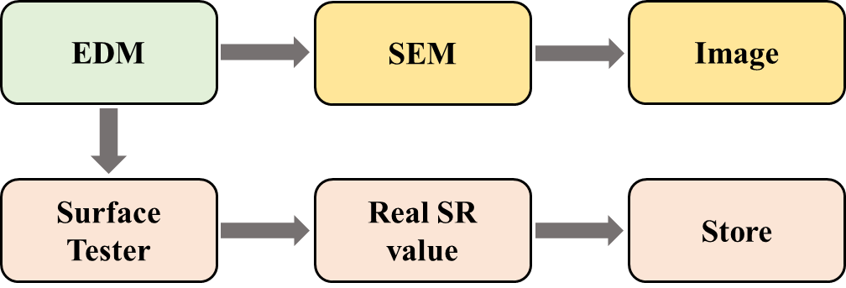

**Figure 2:** Raw image generation procedure

**3.3 Surface Characteristic Image**

Utilizing both positive and negative polarities, along with varying peak currents and pulse on times for three electrodes (Cu, CuW, Gr), we obtained multiple surface roughness (SR) values for the Ti-5Al-2.5Sn alloy. This was achieved through 18 sets of images, each classified by different parameters applied during image generation. The specific machining parameters used to generate all raw images are presented in Table 1.

**Table 1:** Machining parameters and their corresponding SR values

|  |  |  |  |  |
| --- | --- | --- | --- | --- |
| SL No. | Discharge (Peak current mA × Pulse on time µs) | Electric Polarity | Electrode | Surface Roughness (SR) value |
| 229 | 2×95 | Positive | Cu | 0.9862 |
| 230 | 15×180 | Positive | Cu | 2.7543 |
| 241 | 29×320 | Positive | Cu | 5.9965 |
| 239 | 2×95 | Negative | Cu | 1.0593 |
| 231 | 15×180 | Negative | Cu | 4.728 |
| 238 | 29×320 | Negative | Cu | 6.7334 |
| 232 | 2×95 | Positive | CuW | 0.8315 |
| 233 | 15×180 | Positive | CuW | 3.0652 |
| 234 | 29×320 | Positive | CuW | 6.3067 |
| 235 | 2×95 | Negative | CuW | 1.069 |
| 240 | 15×180 | Negative | CuW | 4.3732 |
| 236 | 29×320 | Negative | CuW | 6.7838 |
| 244 | 2×95 | Positive | Gr | 2.0119 |
| 242 | 15×180 | Positive | Gr | 4.553 |
| 237 | 29×320 | Positive | Gr | 6.1157 |
| 243 | 2×95 | Negative | Gr | 3.4227 |
| 245 | 15×180 | Negative | Gr | 9.9842 |
| 246 | 29×320 | Negative | Gr | 15.6117 |

Each set comprises 10 images taken at different magnification levels ranging from 25X to 4000X. For this study, we focused on three specific magnification ranges: 150x, 250x, and 500x. This resulted in a total of 16 sets of images, each containing three magnified versions, thus yielding 16 × 3 images as our original dataset. The raw images collected during this phase are stored for subsequent operations. A representative excerpt of an image within the 150X magnification range is illustrated in Figure 3.

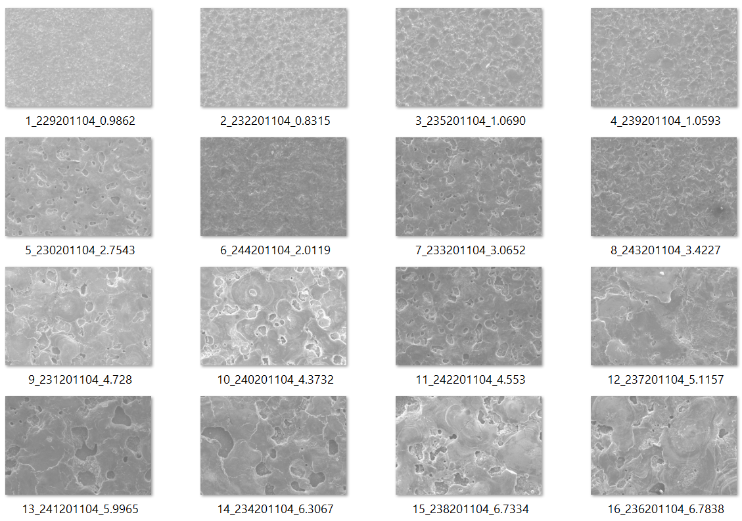

**Figure 3:** First nine collected images of 150X magnification

**3.4 Raw Image Preprocessing**

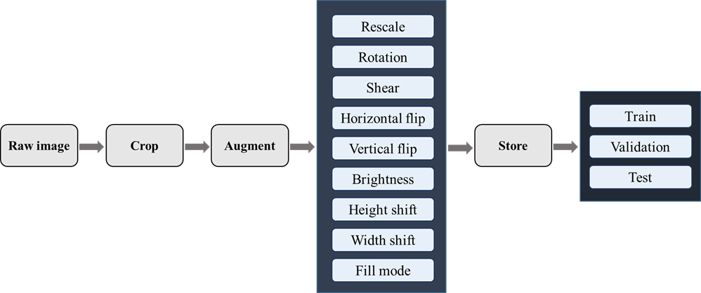Image data preprocessing involves employing a set of techniques to prepare digital images for analysis or other processing. This typically includes removing irrelevant information to ensure accurate input into the CNN model. Such preprocessing simplifies the analysis and interpretation of images, ultimately enhancing the accuracy of subsequent analyses. The process encompasses various steps, such as cropping images, augmenting them, storing the augmented images, and ultimately splitting all the images. Figure 4 visually represents the sequential steps involved in our image data preprocessing.

**Figure 4:** Image preprocessing steps

***Cropping***

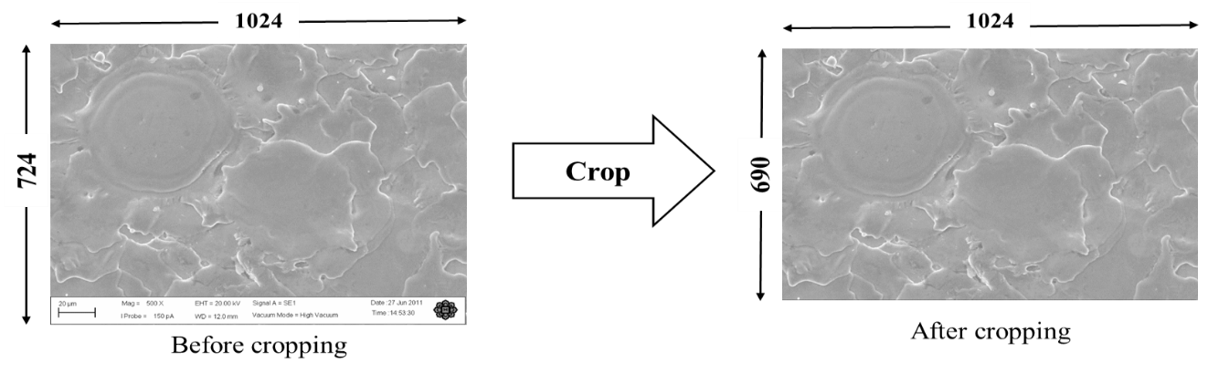Cropping is a process of removing undesired portions of an image to focus on a specific area of interest. This technique is commonly applied to eliminate backgrounds or zoom in on specific objects. In this context, our dataset images undergo cropping, resulting in a dimension change from 724 × 1024 to 690 × 1024. This eliminates unnecessary sections from the image (including SEM parameters), enabling the CNN model to extract the most crucial features. The cropping operation for our dataset is visually depicted in Figure 5.

***Augmentation***

**Figure 5:** Cropping process of an image

Data augmentation involves creating additional images by applying various transformations, such as rotation, flipping, or shearing, to the original images. This process aims to expand the dataset and enhance the model's robustness. In our dataset, we augment images separately at three magnification levels: 150x, 250x, and 500x. This results in a total of 6,302 augmented images derived from the initial 48 images across the three magnifications.

To execute data augmentation, we utilize the *ImageDataGenerator* class from Keras. This class facilitates real-time augmentation during the training of our CNN model by generating batches of image data. The applied properties include:

* Rotation Range: Images are randomly rotated within a 180-degree range.
* Width Shift Range and Height Shift Range: Random horizontal and vertical translation of images within a fraction (0.2) of the total width or height. In our model, the width_shift_range and height_shift_range parameters are set to 0.2.
* Shear Range: Random application of shearing transformations within a range of 0.2.
* Zoom Range: Random application of zooming transformations within a range of 0.1.
* Horizontal Flip and Vertical Flip: Boolean values indicating whether to flip the images horizontally or vertically randomly. Both are set to "True."
* Fill Mode: To fill the pixel value in augmented images after shifting and flipping, we set fill_mode to 'reflect' for better results.
* Brightness Range: Random adjustment of brightness within a specified range (0.3, 1.4).
* Rescale: A scaling factor applied to the pixel values of the images. In our model, rescale is set to 1/255.
* Data Format: The format of the input data, specified as 'channels_last' in our model.

A portion of the augmented images of our dataset is shown in Figure 6.

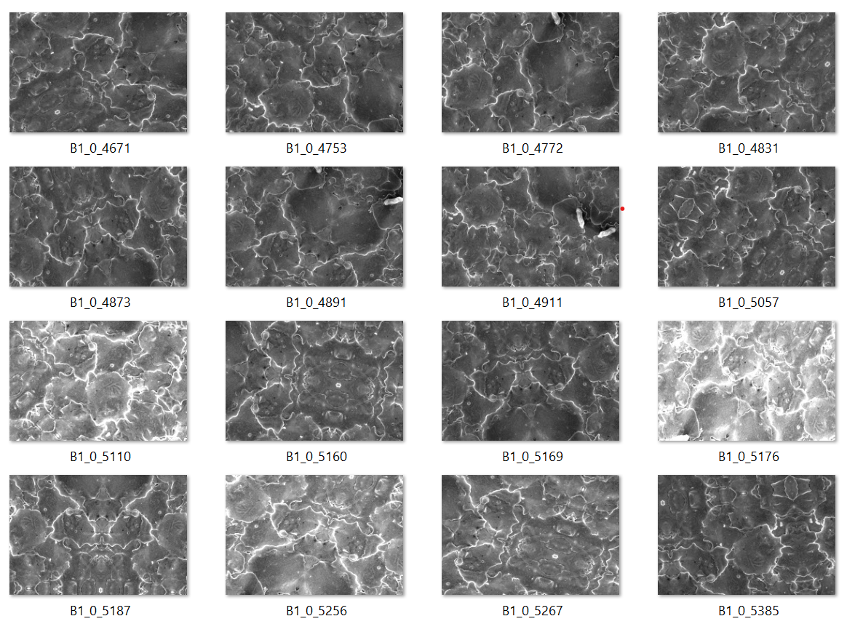

**Figure 6:** A portion of augmented images

***Data Storage and Dataset Frequency***

The image datasets at 150X, 250X, and 500X magnifications are divided into training, validation, and test sets, each comprising seven classes labeled A, B, C, D, E, F, and G. Class A contains images with SR values ranging from 0 to 0.9, while Classes B to G encompass images with SR values in the corresponding range from 1 to 6.9. These classes are defined as keys in a dictionary. Table 2 shows the class corresponding to the SR range, along with its dictionary values**.**

**Table 2:** Classes corresponding to SR value

|  |  |  |
| --- | --- | --- |
| Class | Values | Surface roughness value (µm) |
| A | 0 | 0-0.9 |
| B | 1 | 1-1.9 |
| C | 2 | 2-2.9 |
| D | 3 | 3-3.9 |
| E | 4 | 4-4.9 |
| F | 5 | 5-5.9 |
| G | 6 | 6-6.9 |

All images, totaling 6,302 augmented images across the three magnification sets, are categorized into seven classes. The distribution includes 2,097 images in the 150X magnification set, 2,103 images in the 250X magnification set, and 2,102 images in the 500X magnification set. Figure 7 visually represents the distribution of data among the three magnification sets. The dataset is further utilized in three subsets: the training dataset trains the model, the validation dataset fine-tunes the model's hyperparameters, and the test dataset evaluates the model's performance on unseen data. This division ensures a comprehensive assessment of the model's capabilities across different datasets.

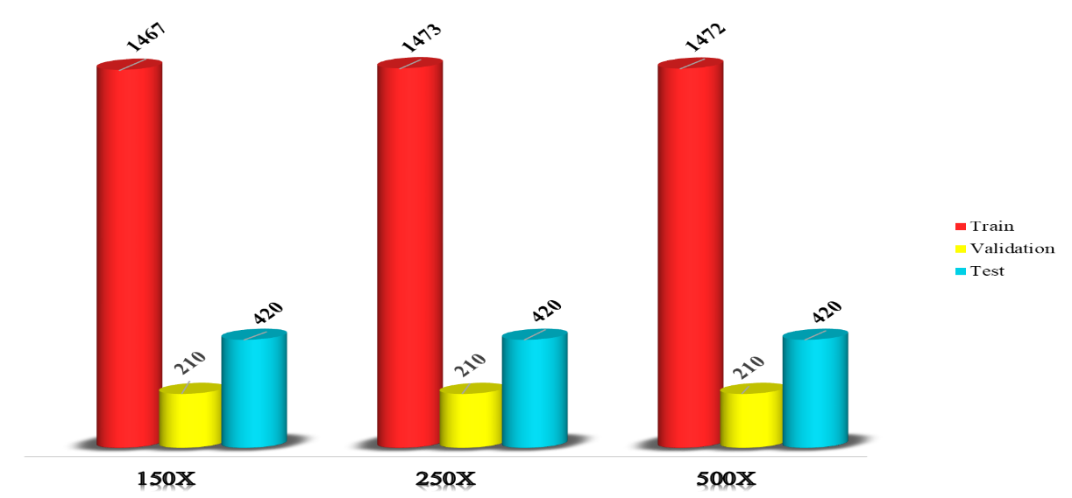

Number of images

Datasets

**Figure 7:** Graphical representation of dataset frequency

**3.5 Convolutional Neural Network for Surface Roughness Prediction**

The sequential CNN model for SR classification from images is a deep learning model designed to classify different levels of SR from images. Our specified CNN model for SR is composed of 27 layers, encompassing four convolutional layers, four max pooling layers, four batch normalization layers, one flatten layer, and eight fully connected dense layers, with an additional six dropout layers. These integrated layers collaborate to extract and accentuate diverse features present in the surface texture, including texture patterns and roughness characteristics. Figure 8 visually illustrates the architecture of the CNN model, providing a comprehensive depiction of all layers involved in feature extraction from images and subsequent output generation. All the layers of the CNN model are briefly described below.

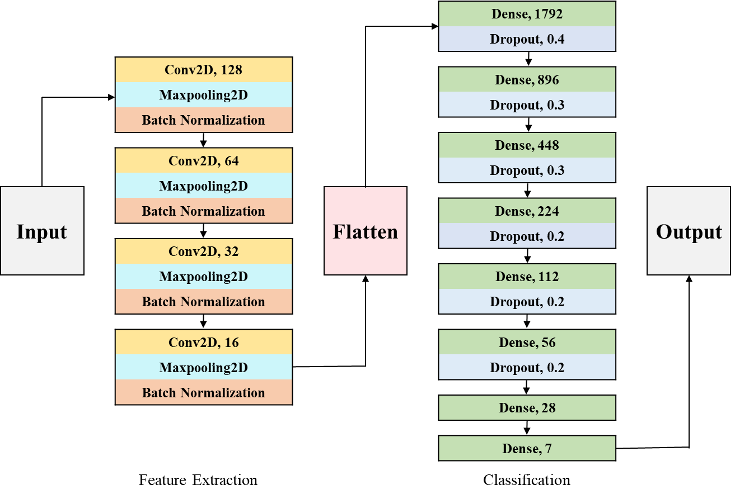

**Figure 8:** Proposed CNN model architecture

***Convolutional Layer***

This layer executes the convolution operation on the input image, involving the systematic movement of a small filter (referred to as a kernel) across the input image to extract distinctive features. In our CNN model, the convolutional layer incorporates 128, 64, 32, and 16 filters, each with dimensions of (5, 5), (3, 3), (3, 3), and (3, 3), respectively. These filters traverse the input tensor, generating 128, 64, 32, and 16 output feature maps. The 'valid' padding scheme is employed, implying that no additional padding is applied to the input image or feature map. Consequently, the size of the output feature maps is dictated by the dimensions of the input tensor and the filter sizes. The Activation layer introduces a Rectified Linear Unit (ReLU) activation function to the convolutional layer's output, incorporating non-linearity into the model.

***Pooling Layer***

This layer reduces the spatial dimensions of the feature maps by performing a pooling operation (e.g., max-pooling or average pooling). This helps reduce the computational complexity of the model and also makes it more robust to slight variations in the input data. In our CNN model, we feed the input feature map to the MaxPooling2D layer. The MaxPooling2D layer employs a 2x2 max pooling operation on the input feature map, thereby reducing its spatial dimensions by a factor of 2 in both height and width directions. During this max pooling operation, the input feature map is partitioned into non-overlapping regions of size (2, 2), and the highest value in each region becomes the output value for that region. This operation effectively trims down the spatial size of the feature map while preserving the most crucial information.

***Batch Normalization Layer***

To normalize the input data for our training, we use batch normalization. Normalization preprocessed the numerical data, bringing them into a standard scale without altering the data shape. The batch normalization process handles a mini-batch at a time, making our CNN more stable and faster. A general formula for batch normalization can be defined as follows;

$z^{N}=\left(\frac{z-m_{z}}{s_{z}}\right)$ (1)

where mz = mean of the neurons’ output and sz = the standard deviation of the neurons’ output.

***Flatten Layer***

A Flatten layer is a type of layer in a NN that flattens the input into a one-dimensional array or vector. It is commonly used between convolutional layers and fully connected layers in a CNN model to convert the output of the convolutional layers into a format that can be passed to the fully connected layers.

***Dropout Layer***

The dropout layer is employed to exclude selected neurons during training randomly. This means that the weights and biases for specific neurons are not updated in the backward pass because the forward pass momentarily ignores the contribution of neuron activations. In our CNN model, six dropout layers are incorporated after the dense layers, with dropout rates set at 0.4, 0.3, 0.3, 0.2, 0.2, and 0.2, respectively. This means that 40%, 30%, 30%, 20%, 20%, and 20% of neuron activations in the forward pass are temporarily omitted. This regularization technique helps prevent overfitting during the training of the CNN.

***Dense Layer***

A Dense layer, also referred to as a fully connected layer, is a type of NN layer where each neuron in the layer is linked to every neuron in the preceding layer. In a Dense layer, each neuron receives input from all neurons in the prior layer and produces a singular value transmitted to each neuron in the subsequent layer. In our CNN model, eight dense layers are present with a varying number of units: 1792, 896, 448, 224, 112, 56, 28, and 7 neurons. The first seven dense layers employ the "ReLU" activation function, which eliminates negative data by providing a direct output if the input is valid; otherwise, it yields zero. The final dense layer constitutes a fully connected layer with seven neurons and utilizes the "softmax" activation function for multiclass classification. The unit parameter specifies the seven classes to be predicted, such as A, B, C, D, E, F, or G.

**3.6 Training and Testing**

***Training***

Training a CNN model encompasses several steps, including defining the model architecture, compiling the model, preparing the training data, fitting the model to the data, and evaluating its performance. Our designated CNN model was fitted to the training data for 80 epochs with a batch size of 16. Figure 9 illustrates some training images from various classes in the 150X magnification set.

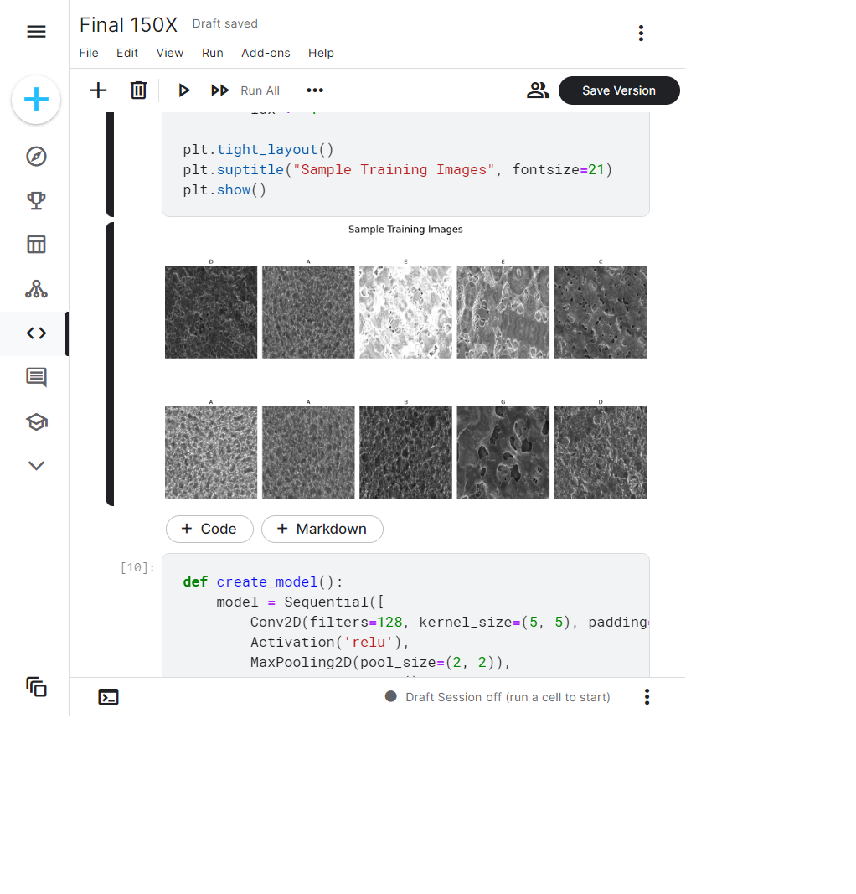

Figure 9. Random training images of different classes

In the training of our CNN model, the compile method is employed to configure the learning process. Specifically, it establishes the optimizer, loss function, and evaluation metrics, which are discussed in the following sections.

**Optimizer**

To enhance the performance of our CNN model, we employ an optimization algorithm that helps reduce the error rate. In this context, the "Adam" optimizer is utilized with a learning rate of 0.0001. Adam is an extension of stochastic gradient descent (SGD) designed to update network weights more efficiently than conventional SGD. It demonstrates computational efficiency and demands less memory than alternative algorithms. The adaptive learning rate feature enables it to adjust the learning rate during training dynamically. The weights in the Adam optimizer are updated using the following equation.

$w_{t}=w_{t-1}-η\frac{{\hat{m}}_{t}}{\sqrt{{\hat{v}}_{t}+ϵ}}$ (2)

where, w = model weights and η = Step size (depend on iteration),

**Loss Function and Metrics**

To assess the performance of our multiclass classification model, we employ the "categorical cross-entropy" loss function. In the context of multiclass classification problems, where an example belongs to only one of several potential categories, categorical cross-entropy serves as a suitable loss function. This function calculates the loss using a specific equation, which is presented below.

$CE=-\sum_{i}^{C}{t_{i}}log⁡(f{\left(s\right)}_{i})$ (3)

Where, ti and si = ground truth.

The metrics parameter is set to evaluate the model using the accuracy metric, which gauges the proportion of correctly classified examples. Throughout training, these metrics track progress and inform decisions on when to conclude the training process. It provides both accuracy and validation during the model training phase.

***Testing***

Testing constitutes a pivotal phase in the development of the CNN model, ensuring its capacity to generalize effectively to new data and deliver robust performance in real-world scenarios. In our study, distinct test datasets corresponding to 150X, 250X, and 500X magnifications are employed, representing the type of data the model is expected to handle and ensuring the reliability of the evaluation process. Figure 10 showcases some test images from various classes within the 150X magnification set. To conduct the testing of our CNN model, we utilize the evaluate method from the model object in Keras. This method takes input from the test images and their corresponding labels, providing the model's accuracy on the test set as output.

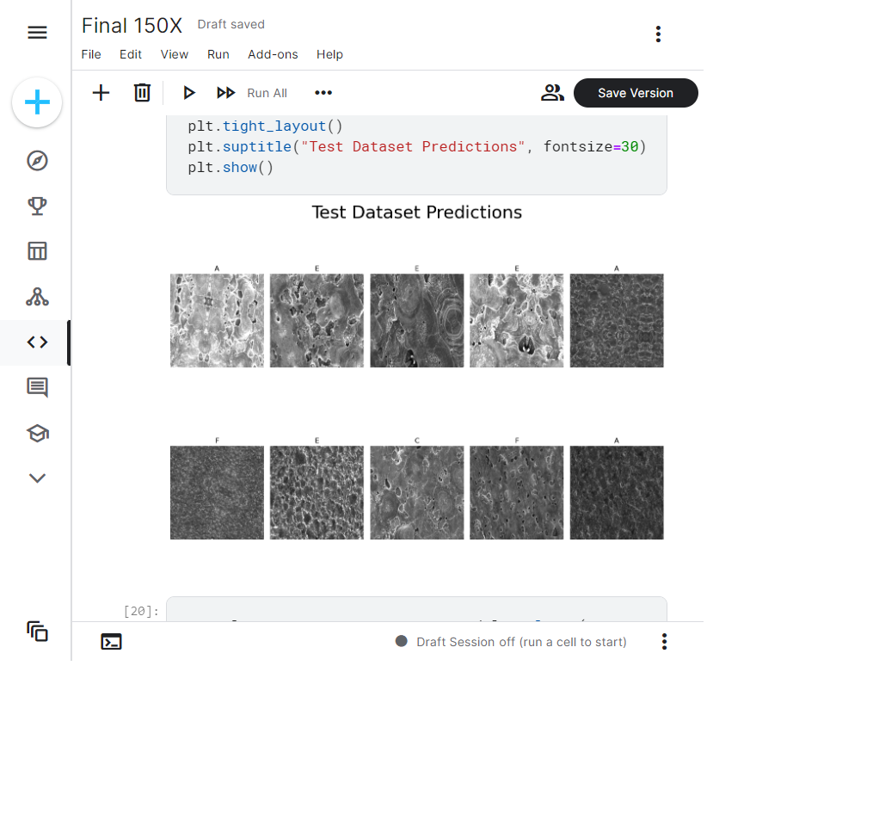**Figure 10:** Some test images of different classes

**3.7 Performance Evaluation Metrics**

Evaluating a CNN model's accuracy and efficiency is crucial to determine its performance. Several performance metrics must be used to comprehend the model's capabilities fully. Furthermore, assessing the effectiveness of the model and highlighting areas for development is made easier by comparing its performance with that of other models. The performance of our CNN model was evaluated using a range of widely used performance metrics. These are described in detail below.

***Confusion Matrix***

A confusion matrix is a table used to evaluate the performance of a classification model, including those based on CNNs. The table compares the actual values of the target variable (accurate labels) with the predicted values generated by the model. The confusion matrix is usually represented as a table with four entries, as shown in Figure 3.11. True positive (TP) represents the number of positive samples correctly classified as positive by the model, false positive (FP) represents the number of negative samples incorrectly classified as positive by the model, true negative (TN) represents the number of negative samples correctly classified as negative by the model, and false negative (FN) represents the number of positive samples incorrectly classified as negative by the model. A confusion matrix provides a visual representation of the model's performance, indicating where the model makes correct and incorrect predictions. It can be used to calculate various performance metrics such as accuracy, precision, recall, F1 score, and others.

***Accuracy***

The most used performance factor in DL is accuracy. It is very easy to interpret the performance of CNNs using accuracy, as it gives a percentage value. Accuracy is the ratio of correct predictions to the total number of classes. It yields better results with the symmetric dataset, where false positives and false negatives are equal. The basic equation for calculating the accuracy is as follows:

$Accuracy=\frac{True Positive+True Negative}{True positive+True Negative+False Positive+False Negative}$ (4)

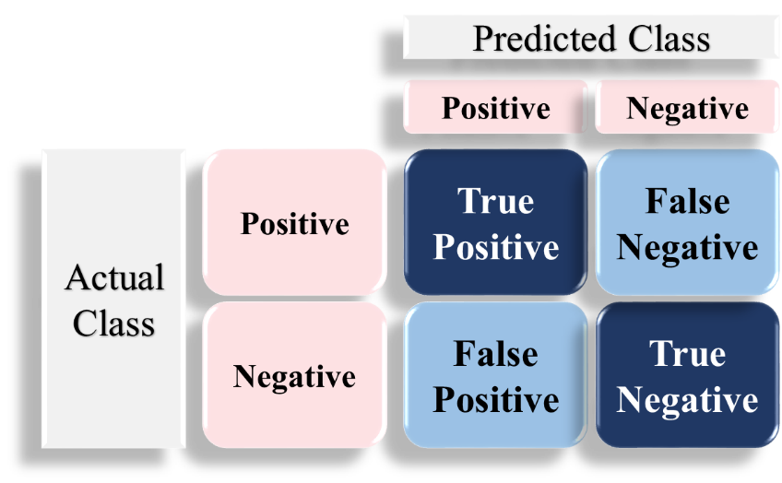

**Figure 11:** Confusion matrix structure

***Precision***

Precision is a performance metric used in classification problems to measure the percentage of actual positive samples out of the total number of positive samples predicted by the model. In the context of CNNs, precision measures the proportion of predicted positive samples that are positive. Precision is an important metric when the cost of a false positive is high. The basic equation for calculating the precision is as follows:

$Precision\frac{ = True Positive}{/True positive + False Positive}$ (5)

***Recall***

Recall is a performance metric used in classification problems to measure the percentage of true positive samples out of the total number of actual positive samples in the test dataset. In the context of CNNs, recall measures the proportion of positive samples in the test dataset that the model correctly identifies. It is defined as:

$Recall = \frac{True Positive}{True positive+False Negative}$ (6)

High recall indicates that the model has a low false negative rate, meaning it correctly identifies positive samples and does not miss any. A low recall indicates a high false negative rate, meaning that the model is missing positive samples, and many positive samples are being classified as negative.

***F1 Score***

F1 score is a performance metric used in classification problems that combines precision and recall to provide a balanced measure of the model's performance. F1 score provides a way to balance the trade-off between precision and recall. In the context of CNNs, the F1 score is the harmonic mean of precision and recall and is defined as:

$F1 score =2× \frac{Precission ×Recall}{Precission+Recall}$ (7)

A high F1 score indicates a model with both high precision and high recall, signifying accurate predictions of positive samples without missing any or falsely categorizing negative samples. Conversely, a low F1 score suggests either low precision or low recall, indicating potential issues with missing positive samples or erroneously classifying negative samples as positive. F1 score is an important metric when the class distribution is imbalanced, meaning that there are more samples in one class than the other. In such cases, accuracy alone may not be a good performance metric, as a high accuracy could be achieved by always predicting the majority class. In these instances, the F1 score provides a more comprehensive measure of the model's performance by considering both precision and recall for each class.

**4. Results and Discussions**

In this chapter, the research results are presented and discussed regarding the study's aim, which was to classify the surface roughness of Ti-5Al-2.5Sn using a CNN model based on an image. We utilized three distinct datasets to predict surface roughness: a 150X magnification set comprising 2,097 images, a 250X magnification set with 2,103 images, and a 500X magnification set containing 2,102 images. Here, the classification performance was assessed separately for each of these datasets, and a comparative analysis of their performances is provided at the end of the chapter. The performance evaluation of a CNN model should be done using multiple performance metrics to get a comprehensive understanding of the model's strengths and weaknesses. Therefore, for performance evaluation, Accuracy, Confusion Matrix, Precision, Recall, and F1 Score metrics are considered in our research. The basis of these metrics is already described in the previous Methodology chapter.

**4.1 SR Prediction Results using 150x Magnified Images Dataset**

The analysis of our CNN model's results involves evaluating its performance on the given image dataset. Specifically, we focused here on the results of a 150X magnified dataset, comprising 2097 images. This dataset was divided into training (1467), testing (420), and validation (210) sets, each categorized into seven classes. The following metrics are used to evaluate the performance of our CNN model for the 150X magnified dataset.

**4.1.1 Training and Validation Result**

The training results in classification reflect how well the model has learned to make accurate predictions on the training data. Here, we considered a total of 1,467 images for training and 210 images for validation in the 150X magnified dataset. During the training process, the model is exposed to a set of labeled examples with 150X magnification, and it learns to map the input features to the output class labels. Figure 12 shows the outputs of the last five epochs during the training process.

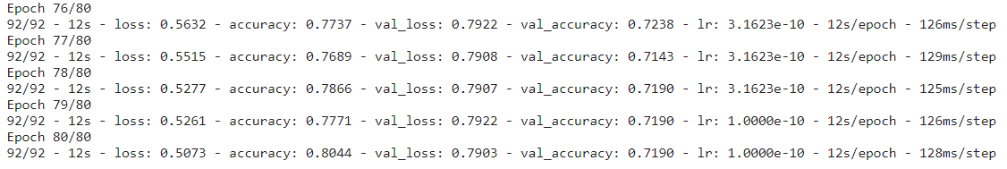

**Figure 12:** Code Snippet of outputs of the last five epochs of the training process

*Training and Validation Accuracy*

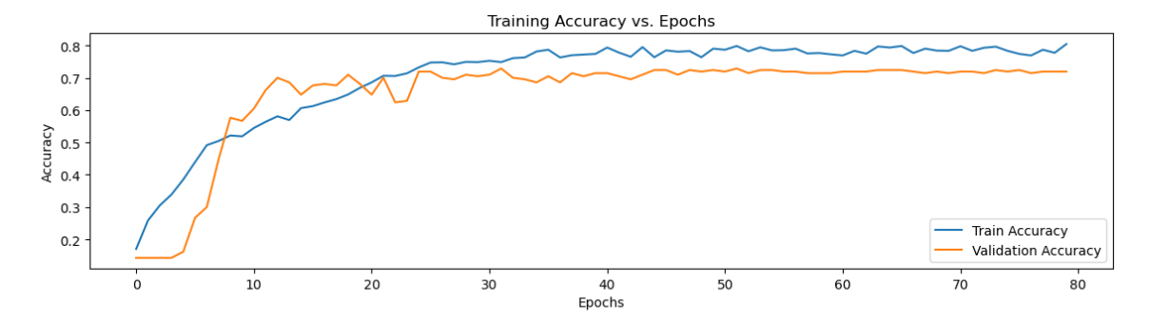

**Figure 13:** Training and validation accuracy for the magnification factor 150X

Accuracy is the most common evaluation metric for classification problems. A high training accuracy indicates that the model can accurately fit the training data. The validation accuracy is the performance metric that measures how well the model generalizes to new, unseen data. Figure 13 shows the accuracy graph for both the training and validation sets. The graph shows that the validation accuracy starts to increase considerably from the fifth epoch and continues to rise until the 15th. After that, it maintains a stable value until the 80th epoch. After 80th epochs, the training accuracy is 0.8044, and the validation accuracy is 0.7190. Here, the difference between training accuracy and validation accuracy is lower. This suggests that the model is generalizing well to new, unseen data and is balanced with the training data. This situation is desirable as it indicates that the model has learned the underlying patterns in the data without simply memorizing the training set.

***Training and Validation Loss***

The training loss measures how well the model fits the training data, while the validation loss measures how well the model generalizes to new, unseen data. Both metrics are essential in evaluating the performance of our CNN model and preventing overfitting. Figure 14 shows the loss graph for both training and validation. During the training of our 150X magnified dataset, the loss is 0.5073 at the last epoch, and the validation loss is 0.7903 at the last epoch. The loss curves for both training and validation are substantially more stable. Training loss and validation loss are highly correlated. Therefore, there is no concern about overfitting.

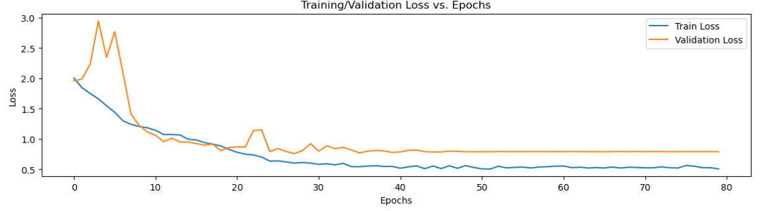

**Figure 14:** Training loss and validation loss curve

**4.1.2 Testing Result**

After training our model on the training set and optimizing it to minimize the loss function, we assess its performance on a separate test set containing 420 new images across seven categories. This evaluation helps us understand how well our CNN model generalizes to fresh, unseen data, measuring its error rate on the new test dataset. The test set estimates the model's generalization error, which is the error rate on new data. The test results are reported using evaluation metrics, such as accuracy, confusion matrix, precision, recall, and F1 score.

***Testing Accuracy***

Test accuracy measures the percentage of instances in the test set that are correctly classified. Table 3 presents the testing accuracy and error for 420 images across seven classes, where each class comprises 60 images for evaluating testing accuracy. As shown in the table, the overall testing accuracy for the 150X magnification factor is 69.5%, with an error of 30.47%. That means the model predicts 69 images accurately out of 100 images.

**Table 3:** Testing accuracy and error for 150X magnification factor

|  |  |  |  |  |
| --- | --- | --- | --- | --- |
| Class | No. of images | Correctly predicted | Incorrectly predicted | Accuracy (%) |
| A | 60 | 41 | 19 | 68.3 |
| B | 60 | 43 | 17 | 71.6 |
| C | 60 | 39 | 21 | 65.0 |
| D | 60 | 43 | 17 | 71.6 |
| E | 60 | 43 | 17 | 71.6 |
| F | 60 | 41 | 19 | 68.3 |
| G | 60 | 42 | 18 | 70.0 |
| Average | 420 | 292 | 128 | 69.5 |

***Confusion Matrix***

The confusion matrix gives a summary of our prediction results. The accuracy metric alone may not accurately interpret the actual result due to variation in the number of observations in each class.

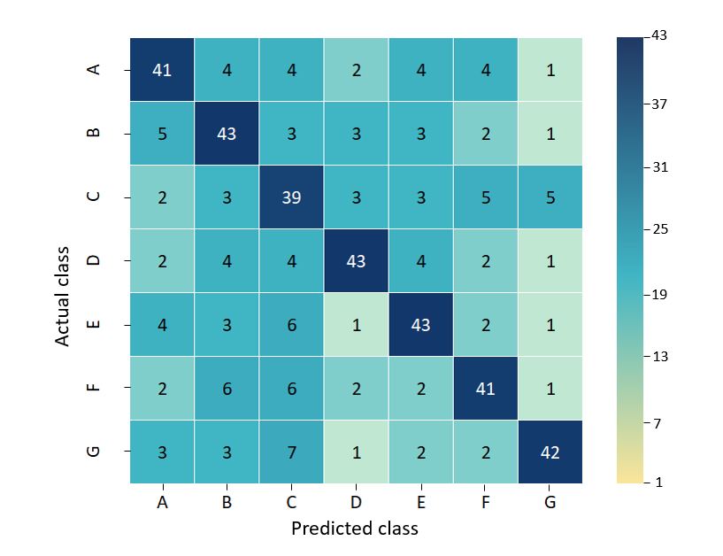

**Figure 15:** Confusion matrix for 150X magnification

In that case, the confusion matrix gives the number of correct and incorrect predictions together, which helps us to interpret the model more easily. Figure 15 shows the confusion matrices for our 150X magnification dataset.

***Precision, Recall, and F1 Score***

We now examine the precision, recall, and F1 score performances in order to present a thorough analysis of our test results. These metrics are calculated individually for all seven classes, and the outcomes are summarized in Table 4, showing the precision, recall, and F1 scores for each class in the 150X magnification dataset.

The weighted average precision, calculated for 420 test images, is 0.71, indicating a high valid positive rate. This implies that the model accurately identifies negative samples. However, there are instances where negative samples are incorrectly classified as positive. The average recall score, determined for 420 test images, stands at 0.69. A high recall score suggests a low false negative rate, indicating that the model correctly identifies positive samples with few instances of misclassifying them as negative. The average F1-score, computed for 420 test images, is 0.70. This indicates that the model strikes a balance between precision and recall, effectively predicting positive samples without significant false positives.

**Table 4:** Precision, recall, and F1 score for 150X magnification

|  |  |  |  |  |
| --- | --- | --- | --- | --- |
| Class | Precision | Recall | F-1 score | Test Images |
| A | 0.69 | 0.68 | 0.69 | 60 |
| B | 0.67 | 0.71 | 0.69 | 60 |
| C | 0.57 | 0.65 | 0.60 | 60 |
| D | 0.76 | 0.71 | 0.73 | 60 |
| E | 0.72 | 0.71 | 0.72 | 60 |
| F | 0.73 | 0.68 | 0.70 | 60 |
| G | 0.80 | 0.70 | 0.75 | 60 |
| Average | 0.71 | 0.69 | 0.70 | 420 |

**4.2 SR Prediction Results using 250x Magnified Images Dataset**

Now, we focus on the results of the 250X magnified dataset, comprising 2,103 images. This dataset was divided into training (1473), testing (420), and validation (210) sets, each categorized into seven classes. The following metrics are used to evaluate the performance of our CNN model for the 250X magnified dataset.

**4.2.1 Training and Validation Results**

The training results in classification reflect how well the model has learned to make accurate predictions on the training data. Here, we considered a total of 1,473 images for training and 210 images for validation in the 250X magnified dataset. During the training process, the model is exposed to a set of labeled examples with 250X magnification, and it learns to map the input features to the output class labels. Figure 16 shows the outputs of the last five epochs during the training process.

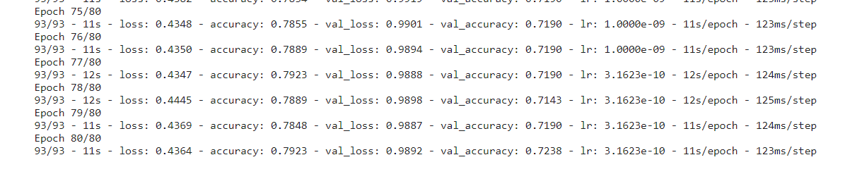

**Figure 16:** Code Snippet of outputs of the last five epochs of the training process

*Training and Validation Accuracy*

Figure 17 shows the accuracy graph for both the training and validation datasets. The graph shows that the validation accuracy starts to increase considerably from the eighth epoch and continues to rise until the 12th. After that, it follows a pattern of decrease and increase until the 25th epoch. After that, it maintains a stable pattern until the 80th epoch. After 80th epochs, the training accuracy is 0.7923, and the validation accuracy is 0.7328. Here, the difference between training accuracy and validation accuracy is lower. This suggests that the model is generalizing well to new, unseen data and is balanced with the training data. This situation is desirable as it indicates that the model has learned the underlying patterns in the data without simply memorizing the training set.

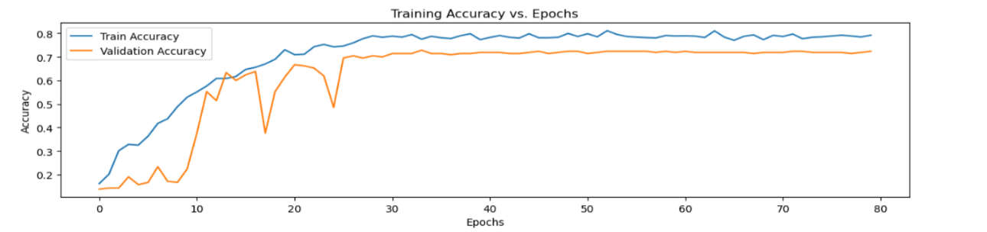

**Figure 17:** Train and validation accuracy for 250X magnified dataset

*Training and Validation Loss*

Figure 18 shows the loss graph for both training and validation. During the training of our 250X magnified dataset, the loss is 0.4364 at the last epoch, and the validation loss is 0.9892 at the last epoch. The loss curves for both training and validation are substantially more stable. Training loss and validation loss are highly correlated. Therefore, there is no concern about overfitting.

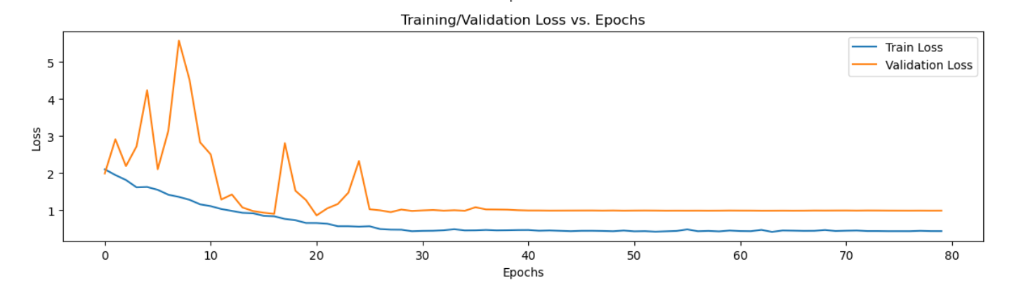

**Figure 18:** Train loss and validation loss curve for 250X magnified dataset

**4.2.2 Testing Result**

After training our model on a training set of 250X magnification dataset and optimizing it to minimize the loss function, we assess its performance on a separate testing dataset containing 420 new images across seven categories. This evaluation helps us understand how well our CNN model generalizes to fresh, unseen data, measuring its error rate on the new test dataset. The test set estimates the model's generalization error, which is the error rate on new data. The test results are reported using evaluation metrics, such as accuracy, confusion matrix, precision, recall, and F1 score.

***Testing Accuracy***

Table 5 presents the testing accuracy and error for 420 images of a 7-class 250X magnification dataset, where each class contains 60 images for determining testing accuracy. As shown in the table, the overall testing accuracy for the 250X magnification factor is 61.90%, with an error rate of 38.10%. That means the model predicts almost 62 images accurately out of 100 images.

**Table 5:** Testing accuracy and error for 250X magnification factor

|  |  |  |  |  |
| --- | --- | --- | --- | --- |
| Class | No. of images | Correctly predicted | Incorrectly predicted | Accuracy (%) |
| A | 60 | 37 | 23 | 61.66 |
| B | 60 | 37 | 23 | 61.66 |
| C | 60 | 34 | 26 | 56.67 |
| D | 60 | 43 | 17 | 71.60 |
| E | 60 | 39 | 21 | 65.00 |
| F | 60 | 33 | 27 | 55.00 |
| G | 60 | 37 | 23 | 61.66 |
| Average | 420 | 260 | 160 | 61.90 |

***Confusion Matrix***

The confusion matrix gives a summary of our prediction results. The accuracy metric alone may not accurately interpret the actual result due to variation in the number of observations in each class. In that case, the confusion matrix gives the number of correct and incorrect predictions together, which helps us to interpret the model more easily. Figure 19 shows the confusion matrices for our 250X magnification dataset.

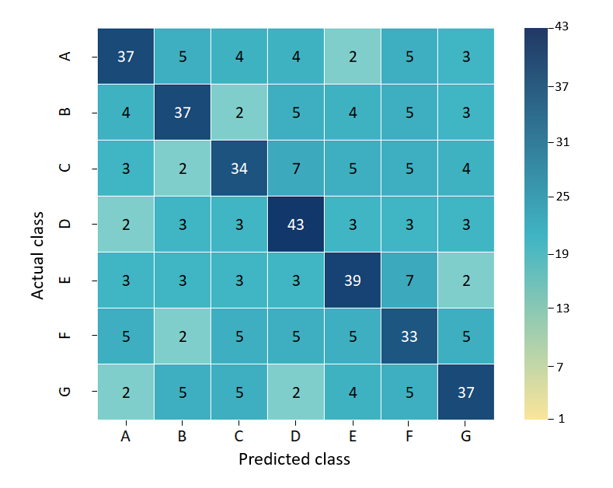

**Figure 19:** Confusion matrix for 250X magnified dataset

***Precision, Recall, and F1 Score***

We now examine the precision, recall, and F1 score performances in order to present a thorough analysis of our test results. These metrics are calculated individually for all seven classes, and the outcomes are summarized in Table 6, showing the precision, recall, and F1 scores for each class in the 250X magnification dataset. The weighted average precision, calculated for 420 test images, is 0.60, indicating a high actual positive rate. This implies that the model accurately identifies negative samples. However, there are instances where negative samples are incorrectly classified as positive. The average recall score, determined for 420 test images, stands at 0.60. A high recall score suggests a low false negative rate, indicating that the model correctly identifies positive samples with few instances of misclassifying them as negative. The average F1-score, computed for 420 test images, is 0.60. This indicates that the model strikes a balance between precision and recall, effectively predicting positive samples without significant false positives. However, all the precision, recall, and F1 score values are comparatively much lower than those for the 150X magnification dataset.

**Table 6:** Precision, recall, and F1 score for 250X magnification

|  |  |  |  |  |
| --- | --- | --- | --- | --- |
| Class | Precision | Recall | F-1 score | support |
| A | 0.63 | 0.61 | 0.62 | 60 |
| B | 0.68 | 0.61 | 0.64 | 60 |
| C | 0.59 | 0.56 | 0.57 | 60 |
| D | 0.66 | 0.71 | 0.69 | 60 |
| E | 0.62 | 0.65 | 0.63 | 60 |
| F | 0.49 | 0.55 | 0.52 | 60 |
| G | 0.59 | 0.61 | 0.60 | 60 |
| Average | 0.60 | 0.60 | 0.60 | 420 |

**4.3 SR Prediction Results using 500x Magnified Images Dataset**

Now, we focus on the results of the 500X magnified dataset, comprising 2,102 images. This dataset was divided into training (1472), testing (420), and validation (210) sets, each categorized into seven classes. The following metrics are used to evaluate the performance of our CNN model for the 500X magnified dataset. The result analysis for 500X magnified images is segmented into three parts: training and validation result analysis, and testing result analysis.

**4.3.1 Training and Validation Results**

The training results in classification reflect how well the model has learned to make accurate predictions on the training data. Here we considered a total of 1472 images for training and 210 images for validation in a 500X magnified dataset. During the training process, the model is exposed to a set of labeled examples with 500X magnification, and it learns to map the input features to the output class labels. Figure 20 shows the outputs of the last five epochs during the training process.

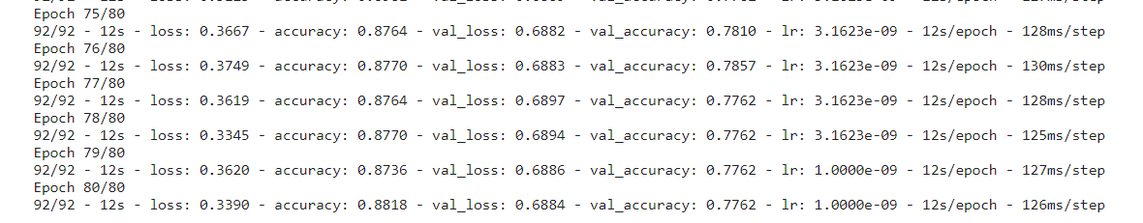

**Figure 20:** Code Snippet of outputs of the last five epochs of the training process

*Training and Validation Accuracy*

Figure 21 shows the accuracy graph for both the training and validation datasets. The graph shows that the validation accuracy starts to increase considerably from the fifth epoch and continues to rise until the 35th. After that, it maintains a stable value until the 80th epoch. After 80th epochs, the training accuracy is 0.8818, and the validation accuracy is 0.7762. Here, the difference between training accuracy and validation accuracy is lower. This suggests that the model is generalizing well to new, unseen data and is balanced with the training data. This situation is desirable as it indicates that the model has learned the underlying patterns in the data without simply memorizing the training set.

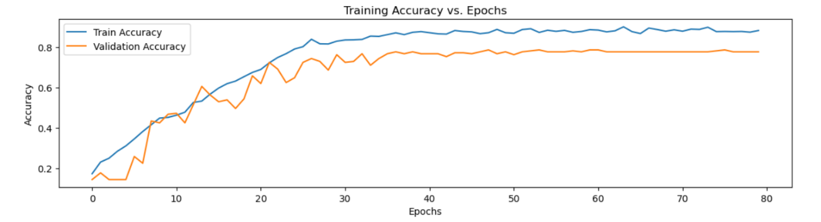

**Figure 21:** Train and validation accuracy for 500X magnified dataset

*Training and Validation Loss*

Figure 22 shows the loss graph for both training and validation. During the training of our 500X magnified dataset, the loss was 0.3390 at the last epoch, and the validation loss was 0.6884 at the same epoch. The loss curves for both training and validation are substantially stable. Training loss and validation loss are highly correlated. Therefore, there is no concern about overfitting.

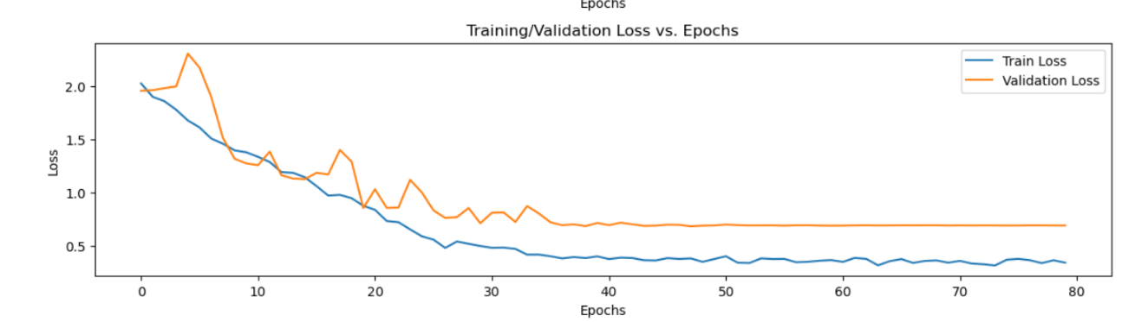

**Figure 22:** Train loss and validation loss curve for 500X magnified dataset

**4.3.2 Testing Result**

After training our model on a training set of 500X magnification dataset and optimizing it to minimize the loss function, we assess its performance on a separate testing dataset containing 420 new images across seven categories. This evaluation helps us understand how well our CNN model generalizes to fresh, unseen data, measuring its error rate on the new test dataset. The test set estimates the model's generalization error, which is the error rate on new data. The test results are reported using evaluation metrics, such as accuracy, confusion matrix, precision, recall, and F1 score.

***Testing Accuracy***

Table 7 presents the testing accuracy and error for 420 images of a 7-class 500X magnification dataset, where each class contains 60 images for determining testing accuracy. As shown in the table, the overall testing accuracy for the 500X magnification factor is 75.71%, with an error rate of 24.29%. That means the model predicts almost 75 images accurately out of 100 images.

**Table 7:** Testing accuracy and error for 500X magnification factor

|  |  |  |  |  |
| --- | --- | --- | --- | --- |
| Class | No. of images | Correctly predicted | Incorrectly predicted | Accuracy (%) |
| A | 60 | 44 | 16 | 73.33 |
| B | 60 | 47 | 13 | 78.33 |
| C | 60 | 44 | 16 | 73.33 |
| D | 60 | 45 | 15 | 75.0 |
| E | 60 | 51 | 9 | 85.0 |
| F | 60 | 43 | 17 | 71.66 |
| G | 60 | 44 | 16 | 73.33 |
| Average | 420 | 318 | 102 | 75.71 |

***Confusion Matrix***

The confusion matrix gives a summary of our prediction results. Figure 23 shows the confusion matrices for our 500X magnification dataset.

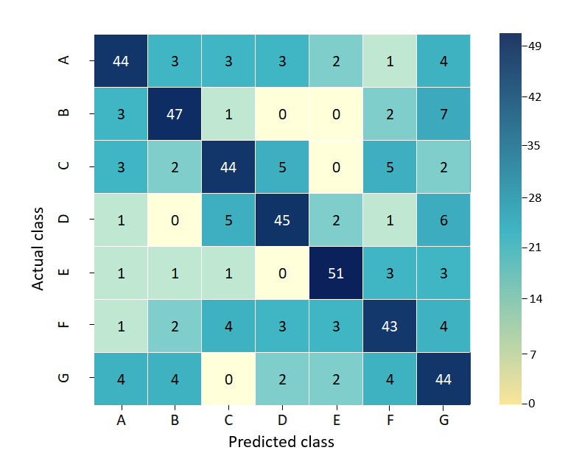**Figure 23:** Confusion matrix for 500X magnified dataset

***Precision, Recall, and F1 Score***

Table 8 shows the precision, recall, and F1 scores for each class in the 500X magnification dataset. The weighted average precision, calculated for 420 test images, is 0.65, indicating a high actual positive rate. This implies that the model accurately identifies negative samples. However, there are instances where negative samples are incorrectly classified as positive. The average recall score, determined for 420 test images, stands at 0.72. A high recall score suggests a low false negative rate, indicating that the model correctly identifies positive samples with few instances of misclassifying them as negative. The average F1-score, computed for 420 test images, is 0.72. This indicates that the model strikes a balance between precision and recall, effectively predicting positive samples without significant false positives.

**Table 8:** Precision, recall, and F1 score for 500X magnification factor

|  |  |  |  |  |
| --- | --- | --- | --- | --- |
| Class | Precision | Recall | F-1 score | support |
| A | 0.78 | 0.78 | 0.78 | 60 |
| B | 0.82 | 0.80 | 0.81 | 60 |
| C | 0.77 | 0.71 | 0.74 | 60 |
| D | 0.76 | 0.80 | 0.78 | 60 |
| E | 0.32 | 0.75 | 0.74 | 60 |
| F | 0.65 | 0.67 | 0.65 | 60 |
| G | 0.51 | 0.56 | 0.54 | 60 |
| Average | 0.65 | 0.72 | 0.72 | 420 |

**4.4 Comparative Analysis among Performance Parameter Scores**

Now, we conduct a comparative analysis of our results across three datasets. In our study, we utilized three distinct image datasets magnified at 150X, 250X, and 500X levels. Figure 24 illustrates the comparative performance, considering training, testing, and validation accuracy for the three datasets. The X-axis represents the three different datasets, while the Y-axis depicts the accuracy scores. Upon examining the comparison chart, it becomes evident that the dataset with images magnified at 500X provides superior accuracy compared to the datasets magnified at 150X and 250X.

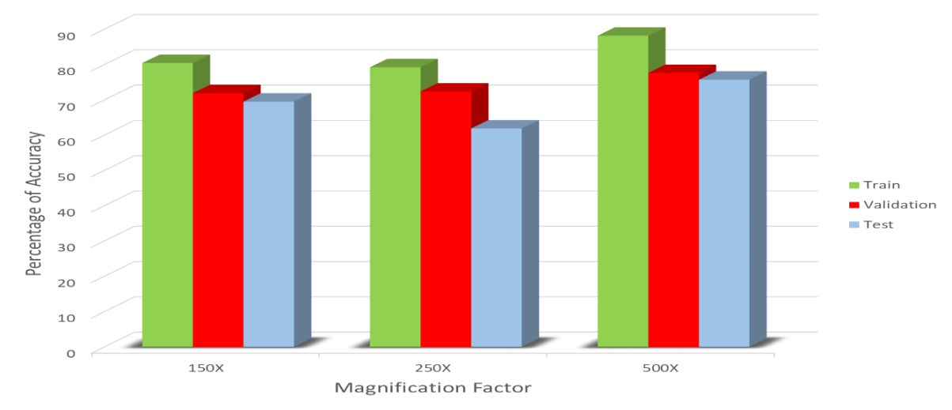

**Figure 24**: Accuracy comparison among three datasets

For a more detailed breakdown of the correctly predicted values and accuracy across all seven classes, Table 9 is presented. The accuracy percentages directly reflect the number of correctly predicted data points for each magnification level. As shown in the table, the 500X magnified images dataset achieves the highest accuracy (75.7%), followed by the 150X (69.5%) and 250X (61.9%) magnifications. The higher accuracy in the 500X dataset implies better overall classification performance at higher magnification levels.

**Table 9:** Comparison Table of Accuracy and Correctly Predicted Data

|  |  |  |  |  |  |  |  |
| --- | --- | --- | --- | --- | --- | --- | --- |
| Class | No. of images | For 150X magnified images | | For 250X magnified images | | For 500X magnified images | |
| Correctly predicted | Accuracy (%) | Correctly predicted | Accuracy (%) | Correctly predicted | Accuracy (%) |
| A | 60 | 41 | 68.3 | 37 | 61.66 | 44 | 73.33 |
| B | 60 | 43 | 71.6 | 37 | 61.66 | 47 | 78.33 |
| C | 60 | 39 | 65.0 | 34 | 56.67 | 44 | 73.33 |
| D | 60 | 43 | 71.6 | 43 | 71.60 | 45 | 75.0 |
| E | 60 | 43 | 71.6 | 39 | 65.00 | 51 | 85.0 |
| F | 60 | 41 | 68.3 | 33 | 55.00 | 43 | 71.66 |
| G | 60 | 42 | 70.0 | 37 | 61.66 | 44 | 73.33 |
| Total | 420 | 292 | 69.5 | 260 | 61.9 | 318 | 75.7 |

Table 10 presents a comparative analysis of precision, recall, and F1-score across three magnification levels (150X, 250X, and 500X) in image datasets. This comparison enables an in-depth evaluation of the model's efficacy at various magnification levels. Across the magnification levels, precision varies, with the 150X dataset achieving the highest precision (0.71), followed by the 500X dataset (0.65), and then the 250X dataset (0.60). The 150X dataset demonstrates superior precision, indicating a better ability to identify positive instances accurately. While the 250X dataset shows the lowest recall (0.60), the 150X and 500X datasets exhibit almost similar recall values (0.69 and 0.72, respectively). The 500X dataset stands out with the highest recall, indicating a better ability to capture all positive instances. Among the three datasets, the highest F1-score is observed in the 500X magnified images dataset (0.72), while the lowest F1-score is found in the 250X magnified images dataset (0.60). This means that the 500X dataset demonstrates superior performance in achieving a balance between precision and recall, whereas the 250X dataset shows relatively weaker performance in this aspect.

**Table 10:** Comparison Table of Precision, Recall, and F1-Score

|  |  |  |  |
| --- | --- | --- | --- |
| **Performance Parameter** | **150X Magnified Images Dataset** | **250X Magnified Images Dataset** | **500X Magnified Images Dataset** |
| **Average Precision** | 0.71 | 0.60 | 0.65 |
| **Average Recall** | 0.69 | 0.60 | 0.72 |
| **Average F1-Score** | 0.70 | 0.60 | 0.72 |

**4.5 Optimal Dataset and its Scores**

Based on the provided data, the 500X magnified images dataset delivers the best results among the three magnification levels evaluated. Here is a detailed description of why the 500X dataset stands out.

**Higher Accuracy:** The 500X magnified images dataset achieves the highest accuracy percentage of 75.7%. This indicates that the model trained on the 500X dataset correctly classified the highest proportion of instances compared to the other magnification levels.

**Balanced Precision and Recall:** Although precision and recall measures may vary across magnification levels, the 500X dataset demonstrates competitive values. It achieves an average precision of 0.65 and an average recall of 0.72, suggesting a good balance between minimizing false positives and false negatives.

**Superior F1-Score:** The F1-score, which combines precision and recall into a single metric, is consistent across the magnification levels. The 500X dataset achieves an average F1 Score of 0.72, indicating robust performance in terms of both precision and recall.

**Effective Identification of Features:** Higher magnification levels, such as 500X, typically provide finer details and more explicit images, enabling the model to identify subtle features with greater accuracy. This results in more precise classification and higher overall performance.

**Real-world Applicability:** In many real-world scenarios, particularly in fields like medical imaging or materials science, where detailed examination of microscopic structures is crucial, higher magnification levels are preferred for accurate analysis and diagnosis. Therefore, a model trained on 500X magnified images is more likely to generalize well and perform effectively in practical applications.

In summary, the 500X magnified images dataset yields the best results due to its higher accuracy, competitive precision and recall, balanced F1-score, and suitability for real-world applications that require detailed analysis of microscopic structures.

**5. Conclusion and Future Research Scope**

**5.1 Conclusion**

Surface Roughness measurement stands as a pivotal parameter with wide-ranging implications across numerous industries, encompassing aerospace, materials science, and medical imaging. This research represents a significant advancement in the field of SR prediction using CNN applied to SEM images. By addressing the gap in existing literature regarding the utilization of CNNs for SR prediction and considering the impact of varying magnification levels, this study provides valuable insights into optimizing surface quality assessment across diverse industries. The findings underscore the critical importance of selecting appropriate magnification levels in SEM imaging for accurate SR prediction. The comparative analysis revealed that the dataset magnified at 500X consistently outperformed those at 150X and 250X, demonstrating superior accuracy, precision, recall, and F1-score. This indicates that higher magnification levels offer finer detail and more explicit images, enabling the CNN model to discern subtle features with increased accuracy. The successful application of CNN in analyzing SEM images for SR prediction represents a significant step forward in surface quality assessment methodologies. By leveraging CNN (a DL technique), this research provides a robust framework for enhancing SR measurement precision and efficiency in various industrial and research domains.

**5.2 Limitations and Future Research Scopes**

This research has contributed valuable insights into optimizing SR measurement methodologies. However, as with any scientific endeavor, there are inherent limitations to consider, along with opportunities for future exploration and advancement. Below, we outline these aspects to provide a comprehensive understanding of the research landscape and potential avenues for further investigation.

* **Limited Dataset:** Despite efforts to collect diverse SEM images, the dataset used in this research may not fully capture the variability present in real-world scenarios. For this limited dataset, the accuracy and other performance metrics deliver comparatively lower scores. Future studies could benefit from larger and more diverse datasets to improve model generalization.
* **Single Material Focus:** This research specifically focused on titanium alloy (Ti-5Al-2.5Sn), potentially limiting the generalizability of findings to other materials. Exploring SR prediction across a broader range of materials could provide a more comprehensive understanding of this phenomenon.
* **Magnification Levels:** Although this study investigated three magnification levels, additional magnification levels or imaging parameters may also impact SR prediction accuracy. Exploring a wider range of magnifications and imaging settings could provide further insights.
* **Evaluation Metrics:** While accuracy, precision, recall, and F1-score were utilized as performance metrics, other evaluation measures such as mean squared error or root mean squared error could provide additional insights into model performance.
* **Enhanced Model Architectures:** Future research could explore more advanced CNN architectures, such as attention mechanisms or capsule networks, to further improve SR prediction accuracy and robustness.

**Author Declarations**

**Funding:** The authors declare that they received no funding from any organization for this research.

**Competing Interest:** The authors declare no competing interest.

**Ethics Approval:** Not applicable.

**Consent to Participate:** All the authors have voluntarily agreed to participate in this research study.

**Consent to Publication:** All the authors have given their consent for the publication of identifiable details, which can include image(s) and/or videos and/or case history and/or details within the text (“Material”) to be published in this Article.

**Availability of Data and Materials:** The data sets generated during the current study are available from the corresponding author upon reasonable request.

**Code Availability:** The Code written and utilized during the current study is available from the corresponding author on reasonable request.

**Author’s Contribution:** **Md. Ashikur Rahman Khan:** Supervision,conceptualization, investigation, data curation, model design, analysis and interpretation of results, Draft manuscript preparation, writing – review and editing. **Md. Shariar Kabir Asif:** Data collection, conceptualization, model design, model training, analysis and interpretation of results, investigation on challenges, writing – original draft. **Ishtiaq Ahammad:** Draft manuscript preparation, investigation, analysis and interpretation of results, writing – review and editing.

**References**

[1] K. Palová, T. Kelemenová, and M. Kelemen, “Measuring Procedures for Evaluating the Surface Roughness of Machined Parts,” *Applied Sciences*, vol. 13, no. 16, p. 9385, Aug. 2023, doi: 10.3390/app13169385.

[2] K. J. Kubiak, T. W. Liskiewicz, and T. G. Mathia, “Surface morphology in engineering applications: Influence of roughness on sliding and wear in dry fretting,” *Tribol Int*, vol. 44, no. 11, pp. 1427–1432, Oct. 2011, doi: 10.1016/j.triboint.2011.04.020.

[3] D. Obilanade, P. Törlind, and C. Dordlofva, “Surface Roughness and Design for Additive Manufacturing: A Design Artefact Investigation,” *Proceedings of the Design Society*, vol. 2, pp. 1421–1430, May 2022, doi: 10.1017/pds.2022.144.

[4] S. Ramesh, L. Karunamoorthy, and K. Palanikumar, “Measurement and analysis of surface roughness in turning of aerospace titanium alloy (gr5),” *Measurement*, vol. 45, no. 5, pp. 1266–1276, Jun. 2012, doi: 10.1016/j.measurement.2012.01.010.

[5] R. Russell *et al.*, “Qualification and certification of metal additive manufactured hardware for aerospace applications,” in *Additive Manufacturing for the Aerospace Industry*, Elsevier, 2019, pp. 33–66. doi: 10.1016/B978-0-12-814062-8.00003-0.

[6] M. Radmilović-Radjenović, B. Radjenović, and Z. L. J. Petrović, “Application of level set method in simulation of surface roughness in nanotechnologies,” *Thin Solid Films*, vol. 517, no. 14, pp. 3954–3957, May 2009, doi: 10.1016/j.tsf.2009.01.123.

[7] B. C. Bovas, L. Karunamoorthy, and F. B. Chuan, “Effect of surface roughness and process parameters on mechanical properties of fabricated medical catheters,” *Mater Res Express*, vol. 6, no. 12, p. 125420, Jan. 2020, doi: 10.1088/2053-1591/ab6652.

[8] T. J. Webster, R. W. Siegel, and R. Bizios, “Nanoceramic surface roughness enhances osteoblast and osteoclast functions for improved orthopaedic/dental implant efficacy,” *Scr Mater*, vol. 44, no. 8–9, pp. 1639–1642, May 2001, doi: 10.1016/S1359-6462(01)00873-9.

[9] Y. W. Ji *et al.*, “Comparison of Surface Roughness and Bacterial Adhesion Between Cosmetic Contact Lenses and Conventional Contact Lenses,” *Eye & Contact Lens: Science & Clinical Practice*, vol. 41, no. 1, pp. 25–33, Jan. 2015, doi: 10.1097/ICL.0000000000000054.

[10] A. Kurup, P. Dhatrak, and N. Khasnis, “Surface modification techniques of titanium and titanium alloys for biomedical dental applications: A review,” *Mater Today Proc*, vol. 39, pp. 84–90, 2021, doi: 10.1016/j.matpr.2020.06.163.

[11] N. Erdman, D. C. Bell, and R. Reichelt, “Scanning Electron Microscopy,” in *Springer Handbook of Microscopy*, Springer, 2019, pp. 229–318. doi: 10.1007/978-3-030-00069-1_5.

[12] N. A. Hameed, I. M. Ali, and H. K. Hassun, “Calculating Surface Roughness for a Large Scale SEM Images by Mean of Image Processing,” *Energy Procedia*, vol. 157, pp. 84–89, Jan. 2019, doi: 10.1016/j.egypro.2018.11.167.

[13] L. Cao, J. Li, J. Hu, H. Liu, Y. Wu, and Q. Zhou, “Optimization of surface roughness and dimensional accuracy in LPBF additive manufacturing,” *Opt Laser Technol*, vol. 142, p. 107246, Oct. 2021, doi: 10.1016/j.optlastec.2021.107246.

[14] F. Martín Fernández and M. J. Martín Sánchez, “Analysis of the Effect of the Surface Inclination Angle on the Roughness of Polymeric Parts Obtained with Fused Filament Fabrication Technology,” *Polymers (Basel)*, vol. 15, no. 3, p. 585, Jan. 2023, doi: 10.3390/polym15030585.

[15] P. Mishra, S. Sood, V. Bharadwaj, A. Aggarwal, and P. Khanna, “Parametric Modeling and Optimization of Dimensional Error and Surface Roughness of Fused Deposition Modeling Printed Polyethylene Terephthalate Glycol Parts,” *Polymers (Basel)*, vol. 15, no. 3, p. 546, Jan. 2023, doi: 10.3390/polym15030546.

[16] M. Kopp and E. Uhlmann, “Prediction of the Roughness Reduction in Centrifugal Disc Finishing of Additive Manufactured Parts Based on Discrete Element Method,” *Machines*, vol. 10, no. 12, p. 1151, Dec. 2022, doi: 10.3390/machines10121151.

[17] N. E. Sizemore, M. L. Nogueira, N. P. Greis, and M. A. Davies, “Application of Machine Learning to the Prediction of Surface Roughness in Diamond Machining,” *Procedia Manuf*, vol. 48, pp. 1029–1040, 2020, doi: 10.1016/j.promfg.2020.05.142.

[18] Z. Li, Z. Zhang, J. Shi, and D. Wu, “Prediction of surface roughness in extrusion-based additive manufacturing with machine learning,” *Robot Comput Integr Manuf*, vol. 57, pp. 488–495, Jun. 2019, doi: 10.1016/j.rcim.2019.01.004.

[19] T. Batu, H. G. Lemu, and H. Shimels, “Application of Artificial Intelligence for Surface Roughness Prediction of Additively Manufactured Components,” *Materials*, vol. 16, no. 18, p. 6266, Sep. 2023, doi: 10.3390/ma16186266.

[20] V. Lyukshin, D. Shatko, and P. Strelnikov, “Methods and approaches to the surface roughness assessment,” *Mater Today Proc*, vol. 38, pp. 1441–1444, 2021, doi: 10.1016/j.matpr.2020.08.122.

[21] M.-H. Tsai, J.-N. Lee, H.-D. Tsai, M.-J. Shie, T.-L. Hsu, and H.-S. Chen, “Applying a Neural Network to Predict Surface Roughness and Machining Accuracy in the Milling of SUS304,” *Electronics (Basel)*, vol. 12, no. 4, p. 981, Feb. 2023, doi: 10.3390/electronics12040981.

[22] W. J. Murdoch, C. Singh, K. Kumbier, R. Abbasi-Asl, and B. Yu, “Definitions, methods, and applications in interpretable machine learning,” *Proceedings of the National Academy of Sciences*, vol. 116, no. 44, pp. 22071–22080, Oct. 2019, doi: 10.1073/pnas.1900654116.

[23] K. Choudhary *et al.*, “Recent advances and applications of deep learning methods in materials science,” *NPJ Comput Mater*, vol. 8, no. 1, p. 59, Apr. 2022, doi: 10.1038/s41524-022-00734-6.

[24] W.-J. Lin, S.-H. Lo, H.-T. Young, and C.-L. Hung, “Evaluation of Deep Learning Neural Networks for Surface Roughness Prediction Using Vibration Signal Analysis,” *Applied Sciences*, vol. 9, no. 7, p. 1462, Apr. 2019, doi: 10.3390/app9071462.

[25] Md. A. R. Khan, M. M. Rahman, K. Kadirgama, M. A. Maleque, and M. Ishak, “Prediction of Surface Roughness of Ti-6Al-4V in Electrical Discharge Machining: A Regression Model,” *JOURNAL OF MECHANICAL ENGINEERING AND SCIENCES*, vol. 1, pp. 16–24, Dec. 2011, doi: 10.15282/jmes.1.2011.2.0002.

[26] Md. A. R. Khan, M. M. Rahman, K. Kadirgama, M. A. Maleque, and R. A. Bakar, “Artificial Intelligence Model to Predict Surface Roughness of Ti-15-3 Alloy in EDM Process,” *World Acad Sci Eng Technol*, pp. 121–125, 2011.

[27] M. M. Rahman, Md. A. R. Khan, M. M. Noor, K. Kadirgama, and R. A. Bakar, “Optimization of Machining Parameters on Surface Roughness in EDM of Ti-6Al-4V Using Response Surface Method,” *Adv Mat Res*, vol. 213, pp. 402–408, Feb. 2011, doi: 10.4028/www.scientific.net/AMR.213.402.

[28] H. SATO, M. O-Hori, and K. Nakayama, “Surface Roughness Measurement by Scanning Electron Microscope,” *CIRP Annals*, vol. 31, no. 1, pp. 457–462, 1982, doi: 10.1016/S0007-8506(07)63347-2.

[29] R. D. Bonetto, J. L. Ladaga, and E. Ponz, “Measuring Surface Topography by Scanning Electron Microscopy. II. Analysis of Three Estimators of Surface Roughness in Second Dimension and Third Dimension,” *Microscopy and Microanalysis*, vol. 12, no. 2, pp. 178–186, Apr. 2006, doi: 10.1017/S143192760606003X.

[30] P. G. Benardos and G.-C. Vosniakos, “Predicting surface roughness in machining: a review,” *Int J Mach Tools Manuf*, vol. 43, no. 8, pp. 833–844, Jun. 2003, doi: 10.1016/S0890-6955(03)00059-2.

[31] A. Sudianto, Z. Jamaludin, and A. Azwan Abdul Rahman, “Prediction of Surface Roughness for Development of Smart Milling Machine,” *J Phys Conf Ser*, vol. 1201, no. 1, p. 012008, May 2019, doi: 10.1088/1742-6596/1201/1/012008.

[32] M. Cheng *et al.*, “Prediction of surface residual stress in end milling with Gaussian process regression,” *Measurement*, vol. 178, p. 109333, Jun. 2021, doi: 10.1016/j.measurement.2021.109333.

[33] M. R. Narayanan, S. Gowri, and M. M. Krishna, “On Line Surface Roughness Measurement Using Image Processing and Machine Vision,” in *Proceedings of the World Congress on Engineering*, London, U.K.: WCE, Jul. 2007.

[34] M. Guo, J. Zhou, X. Li, Z. Lin, and W. Guo, “Prediction of surface roughness based on fused features and ISSA-DBN in milling of die steel P20,” *Sci Rep*, vol. 13, no. 1, p. 15951, Sep. 2023, doi: 10.1038/s41598-023-42968-4.

[35] M. K. O. Ayomoh and K. A. Abou-El-Hossein, “Surface roughness prediction using a hybrid scheme of difference analysis and adaptive feedback weights,” *Heliyon*, vol. 7, no. 3, p. e06338, Mar. 2021, doi: 10.1016/j.heliyon.2021.e06338.

[36] K. Sugsompian, R. Tansalarak, and T. Piyapattamin, “Comparison of the Enamel Surface Roughness from Different Polishing Methods: Scanning Electron Microscopy and Atomic Force Microscopy Investigation,” *Eur J Dent*, vol. 14, no. 02, pp. 299–305, May 2020, doi: 10.1055/s-0040-1709945.

[37] W. Zhang, “Surface Roughness Prediction with Machine Learning,” *J Phys Conf Ser*, vol. 1856, no. 1, p. 012040, Apr. 2021, doi: 10.1088/1742-6596/1856/1/012040.

[38] A. Varun, M. S. Kumar, K. Murumulla, and T. Sathvik, “Surface Roughness Prediction using Machine Learning Algorithms while Turning under Different Lubrication Conditions,” *J Phys Conf Ser*, vol. 2070, no. 1, p. 012243, Nov. 2021, doi: 10.1088/1742-6596/2070/1/012243.

[39] E. Kayahan, H. Oktem, F. Hacizade, H. Nasibov, and O. Gundogdu, “Measurement of surface roughness of metals using binary speckle image analysis,” *Tribol Int*, vol. 43, no. 1–2, pp. 307–311, Jan. 2010, doi: 10.1016/j.triboint.2009.06.010.

[40] M. Ulas, O. Aydur, T. Gurgenc, and C. Ozel, “Surface roughness prediction of machined aluminum alloy with wire electrical discharge machining by different machine learning algorithms,” *Journal of Materials Research and Technology*, vol. 9, no. 6, pp. 12512–12524, Nov. 2020, doi: 10.1016/j.jmrt.2020.08.098.

[41] C.-L. Fan and J.-R. Jiang, “Surface Roughness Prediction Based on Markov Chain and Deep Neural Network for Wire Electrical Discharge Machining,” in *2019 IEEE Eurasia Conference on IOT, Communication and Engineering (ECICE)*, IEEE, Oct. 2019, pp. 191–194. doi: 10.1109/ECICE47484.2019.8942705.

[42] K. Manjunath, S. Tewary, and N. Khatri, “Surface roughness prediction in milling using long-short term memory modelling,” *Mater Today Proc*, vol. 64, pp. 1300–1304, 2022, doi: 10.1016/j.matpr.2022.04.126.

[43] A. R. Babu, “A Machine Learning Approach for Prediction of Surface Roughness from the Images of Machined Components,” 2023, pp. 405–416. doi: 10.1007/978-981-19-3866-5_34.

[44] C. Palande, R. Nadar, P. Ambadekar, K. Sridhar, and T. Vashistha, “Machine Learning Application for Prediction of Surface Roughness of Milled Surface,” Springer, Singapore, 2022, pp. 203–219. doi: 10.1007/978-981-16-9952-8_20.

[45] V. Dubey, A. K. Sharma, and D. Y. Pimenov, “Prediction of Surface Roughness Using Machine Learning Approach in MQL Turning of AISI 304 Steel by Varying Nanoparticle Size in the Cutting Fluid,” *Lubricants*, vol. 10, no. 5, p. 81, May 2022, doi: 10.3390/lubricants10050081.

[46] A. Varun, M. S. Kumar, K. Murumulla, and T. Sathvik, “Surface Roughness Prediction using Machine Learning Algorithms while Turning under Different Lubrication Conditions,” *J Phys Conf Ser*, vol. 2070, no. 1, p. 012243, Nov. 2021, doi: 10.1088/1742-6596/2070/1/012243.

[47] M. Elangovan, N. R. Sakthivel, S. Saravanamurugan, Binoy. B. Nair, and V. Sugumaran, “Machine Learning Approach to the Prediction of Surface Roughness Using Statistical Features of Vibration Signal Acquired in Turning,” *Procedia Comput Sci*, vol. 50, pp. 282–288, 2015, doi: 10.1016/j.procs.2015.04.047.

[48] P. M. Abhilash and A. Ahmed, “Convolutional neural network–based classification for improving the surface quality of metal additive manufactured components,” *The International Journal of Advanced Manufacturing Technology*, vol. 126, no. 9–10, pp. 3873–3885, Jun. 2023, doi: 10.1007/s00170-023-11388-z.

[49] C. Kantzos, J. Lao, and A. Rollett, “Design of an interpretable Convolutional Neural Network for stress concentration prediction in rough surfaces,” *Mater Charact*, vol. 158, p. 109961, Dec. 2019, doi: 10.1016/j.matchar.2019.109961.

[50] C. He, J. Yan, S. Wang, S. Zhang, G. Chen, and C. Ren, “A theoretical and deep learning hybrid model for predicting surface roughness of diamond-turned polycrystalline materials,” *International Journal of Extreme Manufacturing*, vol. 5, no. 3, p. 035102, Sep. 2023, doi: 10.1088/2631-7990/acdb0a.

[51] W.-J. Lin, S.-H. Lo, H.-T. Young, and C.-L. Hung, “Evaluation of Deep Learning Neural Networks for Surface Roughness Prediction Using Vibration Signal Analysis,” *Applied Sciences*, vol. 9, no. 7, p. 1462, Apr. 2019, doi: 10.3390/app9071462.

[52] N. Gerdes, C. Hoff, J. Hermsdorf, S. Kaierle, and L. Overmeyer, “Hyperspectral imaging for prediction of surface roughness in laser powder bed fusion,” *The International Journal of Advanced Manufacturing Technology*, vol. 115, no. 4, pp. 1249–1258, Jul. 2021, doi: 10.1007/s00170-021-07274-1.

[53] A. P. Rifai, H. Aoyama, N. H. Tho, S. Z. Md Dawal, and N. A. Masruroh, “Evaluation of turned and milled surfaces roughness using convolutional neural network,” *Measurement*, vol. 161, p. 107860, Sep. 2020, doi: 10.1016/j.measurement.2020.107860.

[54] C. Boga and T. Koroglu, “Proper estimation of surface roughness using hybrid intelligence based on artificial neural network and genetic algorithm,” *J Manuf Process*, vol. 70, pp. 560–569, Oct. 2021, doi: 10.1016/j.jmapro.2021.08.062.

[55] S. Zeng and D. Pi, “Milling Surface Roughness Prediction Based on Physics-Informed Machine Learning,” *Sensors*, vol. 23, no. 10, p. 4969, May 2023, doi: 10.3390/s23104969.

[56] Q. Hu, H. Xu, and Y. Chang, “Surface roughness prediction of aircraft after coating removal based on optical image and deep learning,” *Sci Rep*, vol. 12, no. 1, p. 19407, Nov. 2022, doi: 10.1038/s41598-022-24125-5.

[57] N. Chaudhary and S. A. Savari, “Simultaneous Denoising and Edge Estimation from SEM Images using Deep Convolutional Neural Networks,” in *2019 30th Annual SEMI Advanced Semiconductor Manufacturing Conference (ASMC)*, IEEE, May 2019, pp. 1–6. doi: 10.1109/ASMC.2019.8791764.

[58] H. Iwata, Y. Hayashi, A. Hasegawa, K. Terayama, and Y. Okuno, “Classification of scanning electron microscope images of pharmaceutical excipients using deep convolutional neural networks with transfer learning,” *Int J Pharm X*, vol. 4, p. 100135, Dec. 2022, doi: 10.1016/j.ijpx.2022.100135.

### 