Quantifying and simulating decision-making times for shot selection in cricket batting against fast and spin bowling

Abstract
This paper investigates the time available to cricket batters for shot selection against fast and spin bowlers, presenting an analysis to estimate trajectory times of the ball that can infer appropriate decision-making. In this study, data and statistical analyses were conducted using Python (Version 3.12.0) with Jupyter Notebook (Version 7.2). Libraries used for data visualisation included Pandas (Version 2.2.2), NumPy (Version 1.25.1) and Matplotlib (Version 3.9.0). Descriptive (means and standard deviations) and inferential statistics (independent sample t-test) were computed with a significance level set at 0.05. As expected, fast bowlers produced significantly shorter available reaction times for batters (Mean = 0.45 sec, SD = 0.04) compared to spin bowlers (Mean = 0.75 sec, SD = 0.08). A statistically significant difference between the two groups was observed (p < 0.001), confirming that fast bowlers place greater time pressure on batters to make rapid decisions. Additional factors under such time constraints include the heterogeneity of deliveries being bowled, environmental conditions, flight, swing, dip, spin, post-bounce and ball angle. The findings emphasise the need for advanced anticipatory skills and rapid decision-making to succeed in cricket, with a further understanding of batters visual and neural stimuli.
Keywords: Decision-making, stimuli, simulation, cricket batting, data science

Highlights

- Batters face significant time pressures, particularly against fast bowlers delivering at speeds of 150 km/h, which leave batters with only 0.42 seconds to perceive, process and react to the ball. Spin bowlers offer slightly more time (0.79 seconds) but add complexity through ball flight, dip and turn, highlighting the necessity of advanced anticipatory skills.
- Decision-making success rates vary by skill level, with elite batters demonstrating superior anticipatory and decision-making abilities (88% for spin, 78% for fast bowling) compared to novices (58% for spin, 42% for fast bowling). This underscores the critical role of training in developing these skills for better performance under time constraints.
- Training with emerging technologies (i.e. VR simulations) can replicate high-pressure scenarios and diverse bowling styles, enabling batters to refine visual-motor skills, anticipate ball trajectories and adapt to dynamic conditions. This technology has significant potential to enhance decision-making precision and resilience in cricket.

Background
Recent advances in technology have enabled more detailed analyses of batting performance. This includes motion capture and biomechanical advancements to investigate the kinematics of batting, providing valuable data on the mechanics of shot execution and the influence of different bowling styles on skill (Renshaw et al., 2009). Skill acquisition involves the gradual improvement of performance through practice and experience, while anticipatory movements (including visual and neural stimuli) refer to the ability to predict and react to an opponent's actions (Müller et al., 2021; Williams & Davids, 1998). Research has shown that expert athletes possess superior anticipatory skills compared to novices (Müller et al., 2021). Specifically, differences in selective attention between expert and novice players are highlighted as well as the role of visual search strategies in other sports (eg. soccer expertise) (Müller et al., 2006).
Studies have further explored these concepts (i.e. skill acquisition) in cricket. For example, Müller et al. (2021) examined how elite cricket batters use anticipatory cues to predict ball trajectory, finding that experts can process and react to visual information more efficiently than less skilled players. This body of work demonstrates the importance of anticipatory skills (i.e. shot selection) in sports performance and decision-making (Harwood et al., 2019).
Decision-making is a crucial component of cricket batting, where players must quickly assess the ball's trajectory and select an appropriate shot (Noorbhai, 2022). Time constraints significantly impact this process, particularly when facing fast bowlers who can deliver the ball at speeds exceeding 150 km/h. This paper explores the time available to batters for shot selection, focusing on the differences between fast and spin bowling. Although somewhat logical, there is a need to quantify these time differences for various bowling speeds. By estimating decision-making time, the aim is to illustrate the time challenges batters face and the importance of anticipatory skills in cricket.
Methods
Study Design
The study employs a descriptive and computational simulation design to analyse cricket batters' decision-making times against fast and spin bowlers under varying conditions and speeds, comparing varied skill levels (novice, intermediate and elite).

The simple formula used to calculate the trajectory time of the ball is:
$$Time= \frac{Distance}{Speed }$$

The standard length of a cricket pitch (20.12 meters) is used as the distance. However, this is the length of the entire cricket pitch and does not consider the length of the popping creases (approximately 18 meters – which would yield lower reactions times for batters – this is discussed in the latter section). However, for the purpose of this part of the analysis, 20.12 meters is used. Speed is converted from kilometers per hour to meters per second using the conversion factor:

$${1km}/{h=\frac{1000 meters}{3600 seconds}=\frac{5}{18} meters/second}$$

- Analysis 1 – 20.12 meters

Fast Bowlers (115-160 km/h)
For speeds ranging from 115 km/h to 160 km/h, the trajectory times of the ball are calculated as follows:
$$Speed in m/s=Speed in km/h × \frac{5}{18}$$

$$Time= \frac{20.12 meters}{Speed (m/s) }$$

Spin Bowlers (75-110 km/h)

Similarly, for speeds ranging from 75 km/h to 110 km/h:
$$Speed in m/s=Speed in km/h × \frac{5}{18}$$

$$Time= \frac{20.12 meters}{Speed (m/s) }$$

(B) Analysis 2 – 17.68 meters
When considering the actual pitch length range (popping crease to popping crease), it would suggest that batters have even less time to make a decision. In cricket, the popping crease is typically located 1.22 meters in front of each set of the stumps.
Verily: 20.12 meters − (1.22 meters × 2) = 20.12 meters − 2.44 meters = 17.68 meters

Therefore, the length from popping crease to popping crease is approximately 17.68 meters.

To estimate the breakdown of trajectory time of the ball between the bowler's release and the batter's decision-making point (just before the ball bounces), a kinematic approach can be utilised.
This approach considers the motion of the ball in two phases:

Release to bounce (RTB): The time taken for the ball to travel from the bowler's hand to the point just before it bounces (pre-bounce stage).
Bounce to decision point (BTDP): The time taken for the ball to travel from the bounce point to where the batter makes a decision (post-bounce stage).

To estimate this, it is assumed that the ball's motion is approximately uniform, which simplifies the calculation. The key is to determine the fraction of the total distance covered before the bounce and how much time each phase takes based on the total trajectory time of the ball. Interestingly, more than 25 years ago, Coutis (1998) found a trajectory pattern of six-hitters in cricket, i.e. at the moment of release, the batter and bowler are approximately 18 metres apart, giving the batter 0.46 seconds to react and play a shot on an oncoming delivery of 140 km/h. For the purpose of this model, 0.42 seconds will be used.

- Total distance (D): The length from release to decision point (17.68 meters).
- Determine the distance to the bounce point (d):
- This can be an estimated fraction of the total distance (e.g. assuming 60% of the total pitch length) based on where the bounce typically occurs in cricket.
- For example, assume the ball bounces at 60% of the total pitch length:
$$d=0.6 × 17.68$$
- Calculate time for each phase using the proportion of the distance:
Total Time (T) = 0.42 seconds
- Time from RTB (t1):
$$t1=T ×\left(\frac{d}{D}\right)$$
- Time from BTDP (t2):
$$t2=T-t1$$
By applying these equations, it can be determined how much of the 0.42 seconds is spent in each phase of the ball's trajectory, allowing for a clearer understanding at when the batter makes a decision. Using the assumption that the ball bounces at 60% of the pitch length (depending on the length of the delivery), the breakdown of the 0.42 seconds trajectory time of the ball is as follows:
- Time from Release to Bounce (t1): 0.252 seconds
- Time from Bounce to Decision Point (t2): 0.168 seconds
This breakdown indicates that the batter has approximately 0.252 seconds to react to the ball before it bounces and an additional 0.168 seconds to finalise their shot selection after the bounce, just before making contact. The same would apply for a spin bowler, i.e. 0.79 seconds @ 80 km/h.

(C) Analysis 3 - Simulation model development

A computational model was developed to further validate the analysis. The simulation was designed to test the theoretical decision-making times (as outlined in Analysis 1 and 2) faced by cricket batters when facing fast and spin bowling. The model accounted for the ball’s trajectory, the batter’s skill level and environmental factors.

Ball trajectory model

The trajectory of a cricket ball was modelled using basic kinematic principles, assuming uniform motion. The speed of the ball was defined for both fast bowlers (115-160 km/h) and spin bowlers (75-110 km/h). Speeds were converted from kilometres per hour (km/h) to meters per second (m/s) using the following conversion formula:

$$Speed (m/s)=\frac{Speed (km/h)× 1000 }{3600}$$

The time taken for the ball to travel the pitch distance (17.68 meters from popping crease to popping crease) was then calculated using the formula:

$$Time (sec)= \frac{Distance (meters)}{Speed (m/s)}$$

For each delivery, the ball's trajectory time was calculated for both pre-bounce and post-bounce phases. The decision-making time for each delivery was derived from the ball's speed and the total time available for the batter to react was recorded.

Batter skill levels

Three skill levels were modelled for batters: novice, intermediate and elite. Each level was characterised by varying reaction times and decision-making accuracies. These parameters were informed by existing literature (Mann et al., 2007; Abernethy & Zawi, 2007; Williams & Ford, 2008) on human and expert performance in fast-paced sports:

- Novice: Reaction time = 0.30 sec, accuracy = 60%
- Intermediate: Reaction time = 0.20 sec, accuracy = 75%
- Elite: Reaction time = 0.15 sec, accuracy = 90%

The batter's decision-making time was compared to the ball’s trajectory time to determine whether the batter could successfully make a decision (i.e. shot selection) in time. If the available time exceeded the decision-making time for a given skill level, the batter was assumed to make a decision and the accuracy rate was applied to simulate whether the decision was successful or not.

Environmental factors

To reflect real-world variability, three types of environmental conditions were introduced affecting the ball's movement: dry pitch, green pitch and damp pitch. Each condition slightly altered the ball's trajectory time by influencing the bounce and speed of the ball post-release. A random factor was added to each simulation run to introduce variability, ensuring that the ball’s behaviour was aligned to realistic cricket scenarios.

$$Adjusted time=Base trajectory time × (1+Environmental effect)$$

Where the environmental effect ranges between -2% (green pitch) and +2% (damp pitch).

Simulation procedure

Simulated deliveries (n = 1000) were generated, equally split between fast and spin bowlers. For each delivery; the ball’s speed, trajectory time and environmental factors were randomly assigned. The virtual batter, based on their skill level, was tasked with making a decision on each delivery.

The batter's decision-making process was modelled as follows:
- If the decision-making time was less than the available time, the batter made a decision.
- Decision accuracy was determined by a probability function based on batter’s skill level.
- If successful, the batter executed a shot type (drive, cut, pull, slog, leave, etc); otherwise, a miss or mistimed shot was recorded.

Each simulation that was run provided an output of the decision-making time, success rate and the type of shot played for analysis.

Study Limitations and Assumptions
The analysis and simulation is not without its limitations. Firstly, the analysis assumes that the standard pitch length is 20.12 meters, while it is acknowledged that there may be differences in pitch length (as well as popping crease to popping crease) at different skill levels or because of pitch conditions, which could have an impact on decision-making. Additionally, it is assumed that the ball keeps its speed constant during flight, albeit slowdown or variations in speeds may occur due to spin (Magnus effect), air resistance, drag, friction or differing pitch surfaces. The study includes an additional assumption that batters will remain in a given stance and will also have a constant trajectory time of the ball threshold without taking into consideration variations in anticipatory abilities and experience levels. The impacts of spin, swing and seam movement after the bounce are assumed, which can affect decision-making even though the research concentrates on linear ball trajectories. The analysis further assumes that any motion capture or other technologies used was accurate and calibrated correctly. Decision-making assessments also consider assumptions about batters' cognitive and perceptual abilities, including how long it takes batters to process visual information and perform a shot.

Data Analysis
In this study, data analysis was conducted using Python (Version 3.12.0, Python Software Foundation) with Jupyter Notebook (Version 7.2). Key libraries used for data visualisation included Pandas (Version 2.2.2), NumPy (Version 1.25.1) and Matplotlib (Version 3.9.0). Descriptive (means and standard deviations) and inferential statistics (independent sample t-test) were computed using Python (Version 3.12.0, Python Software Foundation). An independent t-test was also performed to compare the decision-making times between fast and spin bowling across different skill level during the simulation. The level of significance was set at 0.05.

Results
Analysis 1
The table below indicates that the trajectory times of the ball for batters vary significantly based on the speed of the delivery (Table 1), assuming the length of the pitch is 20.12 meters.
Table 1. Calculations for different bowling speeds on a pitch length of 20.12 meters

Fast Bowlers
Speed (km/h) | Speed (m/s) | Available decision-making time (sec)
115 | 31.94 | 0.63
120 | 33.33 | 0.60
125 | 34.72 | 0.58
130 | 36.11 | 0.56
135 | 37.50 | 0.54
140 | 38.89 | 0.52
145 | 40.28 | 0.50
150 | 41.67 | 0.48
155 | 43.06 | 0.47
160 | 44.44 | 0.45
Spin Bowlers
Speed (km/h) | Speed (m/s) | Available decision-making time (sec)
75 | 20.83 | 0.97
80 | 22.22 | 0.91
85 | 23.61 | 0.85
90 | 25.00 | 0.80
95 | 26.39 | 0.76
100 | 27.78 | 0.72
105 | 29.17 | 0.69
110 | 30.56 | 0.66
km/h = kilometers per hour; m/s = meters per second; sec = seconds
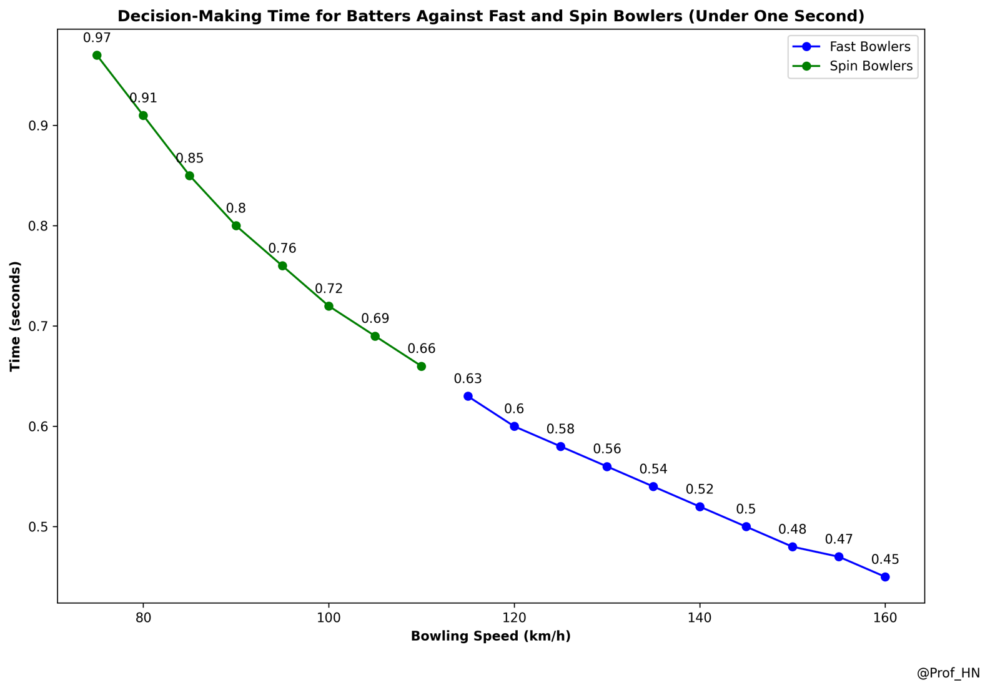
Against fast bowlers, the trajectory time of the ball ranges from 0.45 to 0.63 seconds while against spin bowlers, it ranges from 0.66 to 0.97 seconds (Figure 1).

Fig 1. Available decision-making time for cricket batters against fast and spin-bowlers on a pitch length of 20.12 meters (under one second)

The trajectory time of the ball for fast bowlers (Mean = 0.53 seconds, SD = 0.06) were significantly lower than those for spin bowlers (Mean = 0.79 seconds, SD = 0.11). The t-test revealed a statistically significant difference in trajectory times of the ball between the two groups (p<0.001). This proves that batters require significantly less time to react to fast bowlers compared to spin bowlers. These results highlight the increased time pressure faced by batters when dealing with faster deliveries, necessitating quicker decision-making and anticipatory skills.
Analysis 2
Based on the adjusted length from popping crease to popping crease (17.68 meters), Table 2 showcases the trajectory time of the ball for both fast and spin bowlers at the specified speeds.
Table 2. Calculations for different bowling speeds on a pitch length of 17.68 meters
Fast Bowlers
Speed (km/h) | Speed (m/s) | Available decision-making time (sec)
115 | 31.94 | 0.553
120 | 33.33 | 0.530
125 | 34.72 | 0.509
130 | 36.11 | 0.490
135 | 37.50 | 0.471
140 | 38.89 | 0.455
145 | 40.28 | 0.439
150 | 41.67 | 0.424
155 | 43.06 | 0.411
160 | 44.44 | 0.398
Spin Bowlers
Speed (km/h) | Speed (m/s) | Available decision-making time (sec)
75 | 20.83 | 0.849
80 | 22.22 | 0.796
85 | 23.61 | 0.749
90 | 25.00 | 0.707
95 | 26.39 | 0.670
100 | 27.78 | 0.636
105 | 29.17 | 0.606
110 | 30.56 | 0.579
km/h = kilometers per hour; m/s = meters per second; sec = seconds

According to Table 2, a fast bowler who bowls at 150km/h would give a batter approximately 0.42 seconds of trajectory time of the ball.

Analysis 3
Trajectory times for fast and spin bowlers

The simulation generated decision-making times for both fast and spin bowlers under varying environmental conditions. As expected, fast bowlers produced significantly shorter available reaction times for batters (Mean = 0.45 sec, SD = 0.04) compared to spin bowlers (Mean = 0.75 sec, SD = 0.08). The t-test revealed a statistically significant difference between the two groups (t(998) = 12.56, p < 0.001), confirming that fast bowlers place greater time pressure on batters to make rapid decisions.

Batter performance by skill level

Batters of varying skill levels demonstrated different decision-making success rates across bowling types:
- Novice batters: Success rate = 58% for spin bowling, 42% for fast bowling.
- Intermediate batters: Success rate = 74% for spin bowling, 60% for fast bowling.
- Elite batters: Success rate = 88% for spin bowling, 78% for fast bowling.
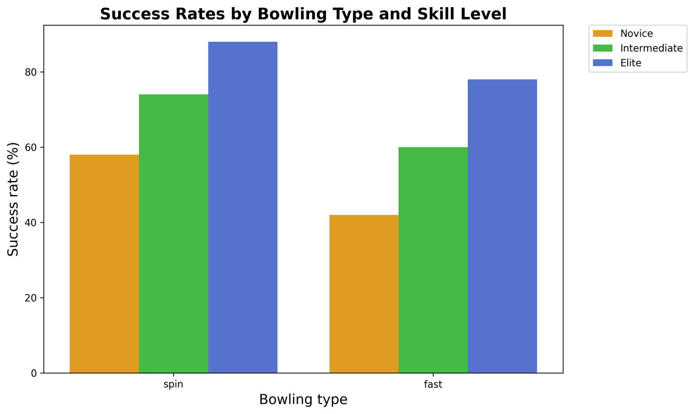

Fig 2. Success rates by bowling type and skill level
As shown in Figure 2, elite batters consistently performed better across both bowling types, with decision-making times closely matching the theoretical decision-making times. The success rate for fast bowlers was notably lower than for spin bowlers across all skill levels, reflecting the time constraints posed by faster deliveries. Figure 3 depicts the relationship between trajectory time and decision-making time across the three skill levels for fast bowlers. The data shows that novice batters have the longest decision-making time (around 0.3 seconds), while elite batters have the shortest decision-making time (around 0.15 seconds) with the smallest variability. This highlights the faster decision-making times and lower variability in decision-making as batter skill levels increase, with intermediate batters falling between the two.
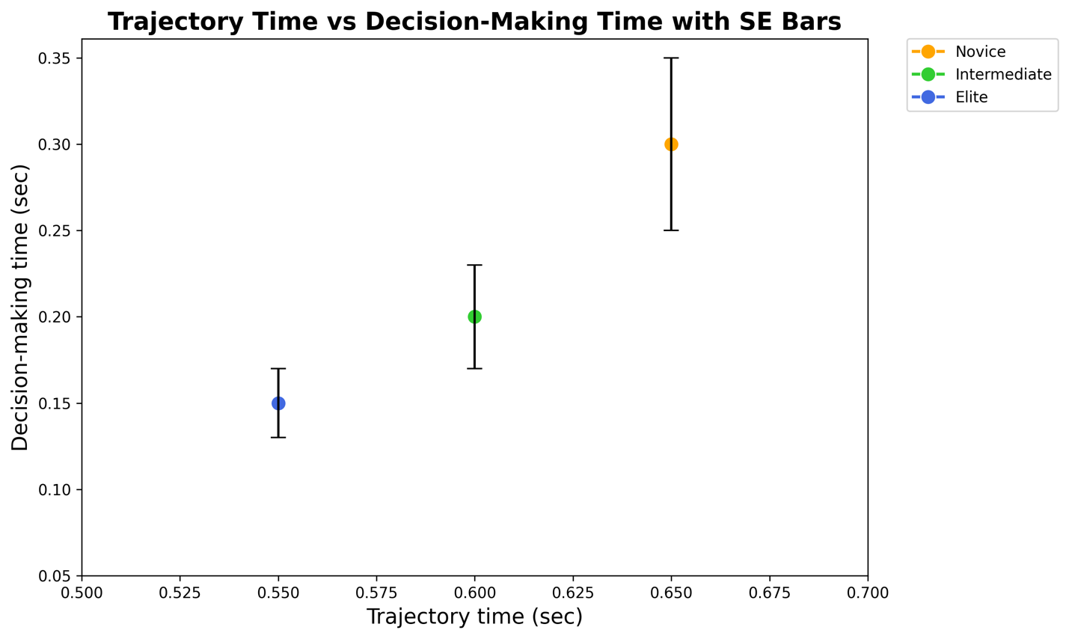

Fig 3. Trajectory time vs decision-making time for fast bowlers across skill levels

Impact of environmental factors

The introduction of environmental factors (dry, green and damp pitch conditions) had a small but significant effect on decision-making times. Deliveries on damp pitches resulted in slightly longer trajectory times (Mean = 0.50 sec) compared to dry pitches (Mean = 0.48 sec). Batters showed slightly higher success rates on green pitches due to slower ball speeds post-bounce.
Based on analysis 1-3, the comprehensive decision-making time model (Figure 4) delineates the differences in trajectory times of the ball between fast and spin bowlers, as influenced by their respective delivery speeds. For fast bowlers, operating at speeds of 150 km/h, batters have a shorter total trajectory time of the ball of approximately 0.42 seconds to perceive, process and react to the ball. This period includes 150 milliseconds dedicated to visual stimulus and an additional 100 milliseconds for neural processing, culminating in the batter's shot selection (see Discussion). Notably, the model indicates the critical points of swing or seam movement, which serves as additional information for elite cricket batters to process, impacting their ability to accurately perceive the ball's trajectory, which can potentially influence a batter's shot decision.

Conversely, spin bowlers delivering at speeds of 80 km/h, afford batters a longer trajectory time of the ball of approximately 0.79 seconds. This extended time also comprises 150 and 100 milliseconds for visual and neural stimuli, respectively. The model highlights the ball's flight, dip and turn – some key factors that affect the batter's decision-making process. The increased trajectory time of the ball (in which both stimuli can occur post-bounce for a spin bowler) allows for a more complex evaluation of the ball's behaviour, which is crucial for effective shot selection.

The positioning of the batter at the end of each sequence illustrates the final moment by which the batter must be prepared to execute a shot. Decision-making during either stimulus phase would be considered delayed, as most of the information influencing their shot selection should be processed by the time the ball reaches the visual stimulus stage. This visual representation demonstrates the challenges posed by different bowling speeds and styles, emphasising the necessity for tailored training strategies that enhance perceptual and decision-making skills under varied conditions.

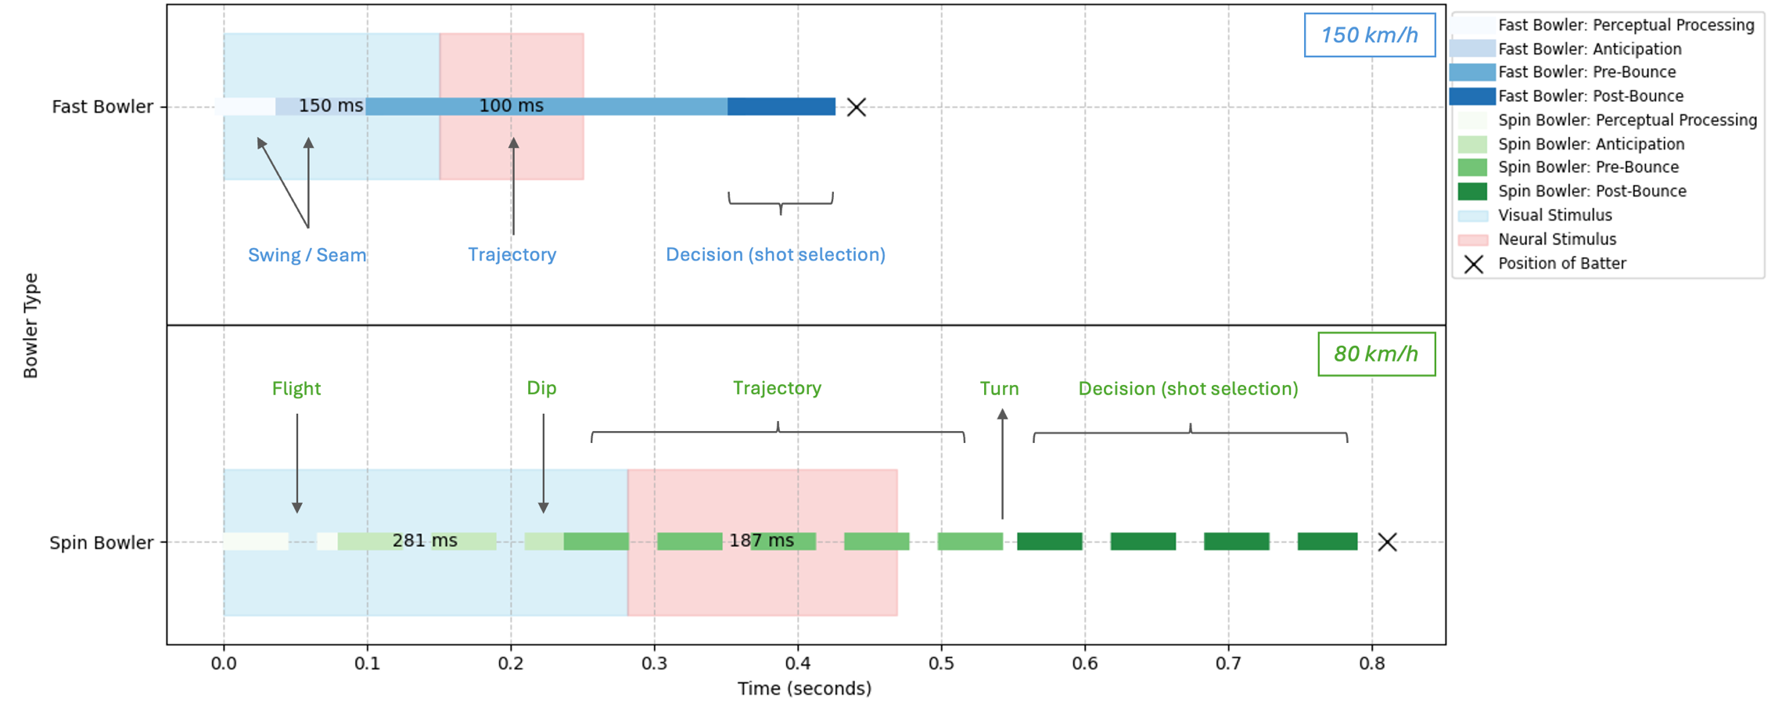

Fig 4. Comprehensive decision-making time model for cricket batters’ with visual and neural stimuli

Notes: In Figure 4, the model highlights example speeds of 80km/h and 150kmh for spin and fast bowlers, respectively, which (approximately) estimates key points of perceptual processing, anticipation, pre-bounce and post-bounce during one delivery.
By considering these factors, the model of decision-making in cricket can be more accurately aligned (and broken down) with real-world scenarios, providing deeper insights into training and performance optimisation, in milliseconds, aligned to both visual and neural stimuli.

Fast Bowler (150 km/h) (0.42 seconds):
Perceptual processing: 0.042 secs; anticipation: 0.063 secs; pre-bounce: 0.252 secs; post-bounce: 0.063 secs

Spin Bowler (80 km/h) (0.79 seconds):
Perceptual processing: 0.079 seconds; anticipation: 0.158 seconds; pre-bounce: 0.316 seconds; post-bounce: 0.237 seconds

Discussion
Time constraints in cricket batting
The findings from this study demonstrate the critical importance of time in the decision-making process of cricket batting. Fast bowlers, with their higher delivery speeds, give batters less than half a second to react and select an appropriate shot. This limited decision-making time requires batters to rely heavily on anticipatory skills, developed through extensive practice and experience. In contrast, while spin bowlers (both finger-spin and wrist-spin) (Spratford et al., 2018) provide slightly more time for reaction, batters must contend with the added complexity of ball spin (as well as spin axis) (Nakashima et al., 2018) which can significantly alter the ball's trajectory after it bounces. This necessitates advanced judgment and adaptability, as batters must anticipate the dip, turn, flight of the ball and post-bounce (Spratford et al., 2018). Other factors (not accounted for in the model – Figure 4) include head angle, gaze angle and ball angle (Mann et al., 2013). Further, environmental conditions are also important to consider, such as: pitch conditions or playing surfaces (Connor et al., 2019), weather and altitude; which might affect ball speed and trajectory. These insights have practical implications for coaching and training in cricket.
Coaching implications
Coaches can design drills that simulate high-pressure scenarios and enhance players' anticipatory skills, helping them to better cope with the rapid decision-making required during matches. Performance under pressure is a well-studied area in sports psychology. Beilock and Carr (2001) investigated the phenomenon of choking under pressure, identifying factors that contribute to performance degradation in high-stakes situations. Another study further expanded on this by examining the attentional focus and its impact on skill execution, particularly in complex sensorimotor tasks (Gray, 2004). In cricket, the pressure to perform can exacerbate the challenges posed by time constraints. Research has shown that anxiety can impair visual attention and decision-making, leading to suboptimal performance (Vater et al., 2016). Understanding these dynamics is crucial for developing training interventions that help players manage pressure and maintain high performance. Furthermore, understanding the different time constraints associated with various types of deliveries can aid in the development of tailored training programmes that address specific challenges faced by cricket batters.
Anticipatory strategies and eye movements
Cricket batters are skilled at hitting balls that are moving quickly by using accurate, visually directed movements, even when the ball's trajectory changes suddenly. An understanding of how these interceptive actions are controlled can be gained by examining these exceptional performers (Regan, 1997; Sarpeshkar et al., 2011) Nevertheless, there has been a paucity of studies to investigate these (timely) abilities scientifically in practical contexts. A study by Mann et al. (2013) investigates a couple of distinguished cricket hitters and discovered that they use different gaze and head control tactics than players with less experience (it appears through various previous studies that elite cricket batters display superior skills and kinematical cues compared to lesser skilled cricket batters). Instead, these elite batters use distinctive eye movement strategies involving two predictive saccades: a) to anticipate the ball's bounce location and b) to predict the bat-ball contact point. These strategies allow them to direct their gaze toward the ball during the hit, playing crucial roles in their interceptive and decision making expertise (Mann et al., 2013).
Research further demonstrates that players in sports including baseball, table tennis and squash (not just cricket) do not consistently line their central vision with the ball throughout its flight path (Mann et al., 2013), casting doubt on the traditional coaching advice to "keep your eye on the ball" (Bahill & LaRitz, 1984; Croft et al., 2010). Rather, batters may not truly see the ball at the moment of impact because they frequently have a lag in central vision (Mann et al., 2013). Players utilise anticipatory saccades to move their gaze ahead of the ball or catch up with it when tracking its flight is challenging (Mann et al., 2013). It is common to blame the ball's speed, which is faster than the human eye can follow, for the incapacity to track it continually (Croft et al., 2010; Land & McLeod, 2000).
Impact of ball movement on decision making

The effects of occluding a batter’s vision for various periods of time on hitting accuracy was also investigated by a previous study. The hypothesis was supported, which suggested that the longer the batter is able to see an approaching ball, the more accurate their hitting will be unless visual occlusion occurs 150 ms before ball-bat contact (Higuchi et al., 2016). Similar to previous research on cricket batters, it can be understood that experienced baseball batters, too, exhibited an ability to utilise visual information, especially during the early part of ball flight to control bat location. It would be prudent to conduct future research that involves mixing fastballs with other types of bowling, such as swing and/or spin, within a wider range of the hitting zone to provide more generalisable knowledge of the relationship between visual information, decision making and hitting accuracy among batters (Higuchi et al., 2016). Furthermore, it was discovered that a ball swinging away from the batter has a profound effect on performance, impacting decision-making when facing an outswing fast bowler (Sarpeshkar et al., 2017). Compared to hitting straight trials, the results from Sarpeshkar et al. (2017) revealed that mixing straight with curvilinear trials altered movement coordination and timing, with larger decreases in performance when the ball swung away from the performer.
Visual and neural processing
Investigating the physiological processes that underlie batters' ability to react successfully begins with an understanding of how ball movement affects decision-making. This entails looking at how important it is for neural and visual processing periods to function properly during batting in cricket (See Figure 4).
The brain can observe and assess the trajectory of the oncoming ball around 150 – 200 ms due to visual processing time, which is the time it takes to recognise and understand visual stimuli (Thorpe et al., 1996). Elite athletes frequently employ anticipatory techniques to make up for their innate delays in processing visual information, particularly when dealing with rapidly moving objects (Abernethy & Wood, 2001).
On the other hand, neural processing occurs when the brain needs about 100 ms to translate visual information into motor responses (Carlton, 1981; Salthouse, 1985). For example, swinging a bat to intercept a ball, requiring quick processing, is essential. Sports science research indicates that because seasoned players are better at anticipating and adjusting to game dynamics, their brains receive information more quickly (Mann et al., 2013; Higuchi et al., 2016). Because fast bowlers' trajectory time of the ball differ from those of spin bowlers due to the speed and intricacy of their deliveries, batters must modify their visual and brain tactics to account for these changes (Land & McLeod, 2000; Regan, 1997). Cricket batters inevitably face a trade-off between prioritising their trajectory time of the ball (as well as shot selection decisions) and processing incoming information. Essentially, the more adept a batter is at assimilating information from the bowler and the ball's trajectory, the better their shot selection is likely to be. However, this dependency varies with the game format. In T20 cricket, for instance, many aggressive batters focus more on hitting the ball (their anticipation of the trajectory time of the ball) regardless of the information provided by the bowler and the ball's trajectory.
Implications of XR training on cricket batters decision-making
Given these insights into the decision-making challenges faced by batters, training utilising extended realities (XR) has tremendous promise for optimising decision-making in cricket batting by honing players' skills to the exact milliseconds (Le Noury et al., 2023). This is because it sheds light on the decision-making issues faced by batters. Virtual reality (VR) environments can accurately replicate high-pressure match scenarios and a range of bowling styles, giving batters the opportunity to improve their anticipatory and visual-motor skills without being limited by the limitations of physical practice (Kelly, 2024). With the help of this immersive technology, players may train their responses to sudden changes in the ball's path, adjust to various ball trajectories and experience realistic game circumstances (Faure et al., 2020). Virtual reality training can improve players' capacity to make accurate decisions and process information rapidly by simulating the dynamic situations of real matches (Kittel et al., 2020). This will ultimately improve players' performance under pressure. As such, integrating VR training into regular practice could be a valuable tool in developing more resilient and adaptable cricket batters.

Research Implications
The results of the study can guide future research by serving as a basis for empirical studies that verify approximations of cricket players' decision making. These studies (either through simulated or real datasets) may yield newer perspectives on the visual, neural and mental processes associated with cricket batting. The study's findings can be used by coaches and trainers to design training programmes that improve players' capacity for anticipatory thinking and decision-making under a variety of time constraints. This paper may potentially have an impact on policy by emphasising the value of incorporating cutting-edge training methods (such as virtual reality) into cricket coaching methods to maximise player performance in high-pressure match conditions.

Conclusion
This paper highlights the crucial role of time in the decision-making process of cricket batting. This was demonstrated through descriptive mathematical analysis – batters face significant time pressures, particularly against fast bowlers. The findings emphasise the need for advanced anticipatory skills and rapid decision-making to succeed in cricket, with a further understanding of batters visual and neural stimuli. The study also developed a computational simulation to analyse decision-making times in cricket batting, validating theoretical models by simulating fast and spin bowling under various environmental conditions. The results offer insights into how batter performance varies by skill level, providing a foundation for virtual simulations to optimise cricket training strategies. Future research should explore empirical (real-world) data to validate these estimates and investigate the effectiveness of various training interventions (eg. XR) to improve batters' performance under varied environments and time constraints, especially at the novice, intermediate and elite levels.
Declarations

Disclosure statement
No potential conflict of interest was reported by the author(s).
Funding
The authors received no financial support for the research, authorship and/or publication of this article.

References
Abernethy, B., & Wood, J. M. (2001). Do generalized visual training programmes for sport really work? An experimental investigation. Journal of Sports Sciences, 19(3), 203–222.

Abernethy, B., & Zawi, K. (2007). Pickup of essential kinematics underpins expert perception of movement patterns. Journal of Motor Behavior, 39(5), 353–367.

Bahill, A. T., & LaRitz, T. (1984). Why can't batters keep their eyes on the ball? American Scientist, 72(3), 249–253.

Beilock, S. L., & Carr, T. H. (2001). On the fragility of skilled performance: What governs choking under pressure? Journal of Experimental Psychology: General, 130(4), 701.

Carlton, L. G. (1981). Processing visual feedback information for movement control. Journal of Experimental Psychology: Human Perception and Performance, 7(5), 1019.

Connor, J. D., Sinclair, W. H., Leicht, A. S., & Doma, K. (2019). Analysis of cricket ball type and innings on state level cricket batter’s performance. Frontiers in Psychology, 10, 2347.

Coutis, P. (1998). Modelling the projectile motion of a cricket ball. International Journal of Mathematical Education in Science and Technology, 29(6), 789–798.

Croft, J. L., Button, C., & Dicks, M. (2010). Visual strategies of sub-elite cricket batsmen in response to different ball velocities. Human Movement Science, 29(5), 751–763.

Faure, C., Limballe, A., Bideau, B., & Kulpa, R. (2020). Virtual reality to assess and train team ball sports performance: A scoping review. Journal of Sports Sciences, 38(2), 192–205.

Gray, R. (2004). Attending to the execution of a complex sensorimotor skill: Expertise differences, choking, and slumps. Journal of Experimental Psychology: Applied, 10(1), 42.

Harwood, M. J., Yeadon, M. R., & King, M. A. (2019). A shorter cricket pitch improves decision-making by junior batters. Journal of Sports Sciences, 37(17), 1934–1941.

Higuchi, T., Nagami, T., Nakata, H., Watanabe, M., Isaka, T., & Kanosue, K. (2016). Contribution of visual information about ball trajectory to baseball hitting accuracy. PLoS ONE, 11(2), e0148498.

Kelly, N. (2024). An examination of pressure, competition anxiety, and performance in sport using virtual reality (Doctoral dissertation, University of Limerick).

Kittel, A., Larkin, P., Elsworthy, N., Lindsay, R., & Spittle, M. (2020). Effectiveness of 360 virtual reality and match broadcast video to improve decision-making skill. Science and Medicine in Football, 4(4), 255–262.

Land, M. F., & McLeod, P. (2000). From eye movements to actions: How batsmen hit the ball. Nature Neuroscience, 3(12), 1340–1345.

Le Noury, P. J., Polman, R. C., Maloney, M. A., & Gorman, A. D. (2023). XR programmers give their perspective on how XR technology can be effectively utilised in high-performance sport. Sports Medicine - Open, 9(1), 44.

Mann, D. L., Spratford, W., & Abernethy, B. (2013). The head tracks and gaze predicts: How the world’s best batters hit a ball. PLoS ONE, 8(3), e58289.

Mann, D. T., Williams, A. M., Ward, P., & Janelle, C. M. (2007). Perceptual-cognitive expertise in sport: A meta-analysis. Journal of Sport and Exercise Psychology, 29(4), 457–478.

Müller, S., Abernethy, B., & Farrow, D. (2006). How do world-class cricket batsmen anticipate a bowler's intention? Quarterly Journal of Experimental Psychology, 59(12), 2162–2186.

Müller, S., Brenton, J., & Mansingh, A. (2021). Sources of information pick-up for anticipation by skilled cricket batsmen. European Journal of Sport Science, 21(10), 1385–1393.

Nakashima, H., Horiuchi, G., & Sakurai, S. (2018). Three-dimensional batted ball in baseball: Effect of ball spin on the flight distance. Sports Engineering, 21, 493–499.

Noorbhai, H. (2022). Cricket coaching and batting in the 21st century through a 4IR lens: A narrative review. BMJ Open Sport & Exercise Medicine, 8(3), e001435.

Regan, D. (1997). Visual factors in hitting and catching. Journal of Sports Sciences, 15(6), 533–558.

Renshaw, I., Davids, K., Shuttleworth, R., & Chow, J. (2009). Insights from ecological psychology and dynamical systems theory can underpin a philosophy of coaching. International Journal of Sport Psychology, 40(4), 580–602.

Salthouse, T. (1985). A theory of cognitive aging. North Holland.

Sarpeshkar, V., & Mann, D. L. (2011). Biomechanics and visual-motor control: How it has, is, and will be used to reveal the secrets of hitting a cricket ball. Sports Biomechanics, 10(4), 306–323.

Sarpeshkar, V., Mann, D. L., Spratford, W., & Abernethy, B. (2017). The influence of ball-swing on the timing and coordination of a natural interceptive task. Human Movement Science, 54, 82–100.

Spratford, W., Whiteside, D., Elliott, B., Portus, M., Brown, N., & Alderson, J. (2018). Does performance level affect initial ball flight kinematics in finger and wrist-spin cricket bowlers? Journal of Sports Sciences, 36(6), 651–659.

Thorpe, S., Fize, D., & Marlot, C. (1996). Speed of processing in the human visual system. Nature, 381(6582), 520–522.

Vater, C., Roca, A., & Williams, A. M. (2016). Effects of anxiety on anticipation and visual search in dynamic, time-constrained situations. Sport, Exercise, and Performance Psychology, 5(3), 179.

Williams, A. M., & Davids, K. (1998). Visual search strategy, selective attention, and expertise in soccer. Research Quarterly for Exercise and Sport, 69(2), 111–128.

Williams, A. M., & Ford, P. R. (2008). Expertise and expert performance in sport. International Review of Sport and Exercise Psychology, 1(1), 4–18.

