Class Imbalance Learning of Defective Prone Modules Using Adaptive Neuro Fuzzy Inference System
Satya Srinivas Maddipati¹, Dr. G Pradeepini², Dr A Yesubabu³
1.Research Scholar K L University, Vijayawada,maddipativas@gmail.com
2. Professor CSE Dept., K L University,pradeepini_cse@kluniversity.in
3. Prof. & HOD CSE Dept., Sir C R Reddy College of Engineering,Eluru,adimulam9@gmail.com

Abstract:
Defect Identification is a major challenge in Software Development Process. Identifying a Defect in early stages reduces the cost of Software Development rather than the later stages. This motivates Demand for applying Data mining techniques for Predicting Software Defects. But the datasets available for predicting software defects are imbalance in nature. Due to imbalance nature of data available, the classifier performance will be degraded even though the classifier has low error rate. To improve the performance of classifier, In this paper, we applied Cost Sensitive Adaptive Neuro Fuzzy Inference System(CSANFIS). The performance of the classifier is measured using AuC(Area under ROC curves) values. We observed AuC value for CSANFIS was high compared to existing different over sampling & under sampling methods.
Keywords: ANFIS, Area under ROC curve, Cost Sensitive, Under sampling, Over Sampling
1.Introduction
The quality of software depends on the bugs reported at maintenance. Identifying a defect in maintenance phase of Software pays more cost than identifying the defect in early stages. This, Identifying a defect in early stages, motivates the injection of data mining algorithms into software defect prediction. There are number of attributes that effects the defectiveness of software. During 1970’s Akiyama found that the number of defects depends on Lines of Code. But later Mc Cube found Cyclometric complexity measures that effects the software defects. Halsted found Halsted metrics for software defect prediction. Later number of researchers applied various data mining algorithms for software defect prediction since the 1990s. The Datasets they considered are downloaded from NASA dataset repositories. The datasets include the following attributes.
Total_loc, Blank_loc, Call_pairs, Design_complexity, Design_density, Halsted_level, Halsted_length, Cyclometric_density, Normalized_ cyclometric_complexity, Code&comment_loc, Multiple_condition_count, Decision_density, Unique_operands, Unique_operators, Total_ Operands, Total_operators, Halsted_vocabulary, Halsted_volume, Halsted_level, Halsted_difficulty, Halsted_effort, Hallsted_error, Halsted_time, Comment_loc, executable_loc.
Imbalance nature of Data
The data to be classified may be imbalance in nature, means that, great differentiation in the strength of samples belonging to different classes. Imbalance nature occurs even in Binary classification as well as multinomial classification. For example consider software defect prediction datasets, there are two classes defective, non defective. The strength of defective samples is high compared to non defective.
This imbalance nature of data bias the classifier towards majority class compared to minority class. Due to this biasing there will be high probability for minority class samples to be classified as majority class samples. This degrades the performance of classifier on minority class even though the overall accuracy of the classifier is high. Hence the performance of classifier for imbalanced datasets has to be measured in terms of AuC (Area Under ROC curves) instead of Accuracy. The SDP datasets that are downloaded from NASA data repository are imbalanced. The imbalance ratio for software defect prediction is 1:10. But this ratio was very high in remaining imbalanced datasets e.g, intruder detection, fraud identification. For classifying imbalanced datasets, traditional classification algorithms may not be suitable.
The class imbalance problem can be solved at Data level and Algorithm level. At the Data level, the rebalancing of the data distribution is done by re sampling the data space including under sampling( Removing the samples from majority class), over sampling( Adding the samples to minority class). At the Algorithm level, the solutions adopt the existing classifier algorithms to bias towards minority class. In this paper we are using cost sensitive approach for constructing a classifier from imbalanced data sets.
Cost sensitive Classification
A cost sensitive classification considers different costs for misclassifying different classes. A cost matrix specifies these misclassification costs. C(i,j) specifies the penalty for misclassifying class j sample as class i. c(i,i) is zero as there is no penalty for correct classification.
The cost matrix c(i,j) is constructed from imbalanced distribution of data. The misclassification cost is calculated by using the formulae C(i,j)=C_{j}*(N/∑C_{i}.N_{i}) Where C_{i} is the weight of the class ‘i’ and N_{i} is the number of sample from class ‘i’. A cost sensitive classification considers the cost matrix during model building and generates a model that has the lowest cost.

2.Literature survey
A lot of Research has been done on learning from imbalanced data. A survey paper was published bu Haibo He[1]. Mikel Galer reviewed on Ensembles algorithms Bagging, Boosting and hybrid based approaches for class imbalance problem[2]. Cristiano L applied Cost sensitive approach for multi layer Perceptron on Imbalanced Data. Based on statistical analysis of results on real data, their approach showed a significant improvement of the area under ROC curve and G-mean measures of Multi layer Perceptrons. Shaoning pang addressed the class imbalance learning using incremental Linear proximity support Vector machines[4]. Claudia Diamantini applied statistical decision theory for class Imbalance[5]
Rukshan Batuwita implemented Fuzzy Support Vector Machines for Class Imbalance Problem. In FSVMs, training examples are assigned with different fuzzy membership values depending on their importance. He evaluated the proposed FSVM with five other class imbalance learning methods and concluded that FSVM is very effective for datasets consisting of outliers & noise[6]. We Proposed Adaptive Neuro Fuzzy Inference System for Cost sensitive class Imbalance learning[7]. We implemented ANFIS on Software Defect Prediction dataset (Imbalanced) and compared the results with existing Neural networks using Back Propagation[8].
3. Input selection for Model
Feature Selection
Input variable selection plays a vital role in modeling complex system where input-output relation is often not too well understand. Large number of inputs unnecessarily over fits the model. The aim of Input selection is to remove weekly relevant or irrelevant attributes that have little influence on the output. There are various methods for reducing the data by identifying weekly irrelevant attributes like correlation analysis[13], principle component analysis.
We applied Principle Component analysis on Software Defect Prediction dataset for identifying weekly relevant or irrelevant attributes in the dataset. Any numeric variables with relatively large rotation values (negative or positive) in any of the first few components are generally variables that we may wish to include in the modeling[23]. We observed Essential Density, Parameter count, Normalized cyclomatic complexity, Decision density and maintenance severity as weekly relevant attributes. We removed these attributes from dataset and constructed the model and observed that the ROC value has been raised compared to original dataset. Hence Principle Component Analysis can be applied as Input selection method for constructing model.
Cost Sensitivity
In Software Defect Prediction, the data to be classified is Imbalanced. Majority of the samples are non defective while minority of samples are defective. Even though defective samples are minor, predicting them as non defective pays more cost(penalty)[19]. Hence we are proposing high(low) cost for minority (majority) class to minimize the overall risk associated with mis classification. But the cost values are not present for most of the real world datasets. These values are derived from the strength of the classes by using the following formulae.
C_{j}=W_{j}*(N/∑W_{i}.N_{i}) where W_{i} is the weigth of class ‘i’ and N_{i} is the number of samples
For example Consider kc1(SDP) dataset, downloaded from NASA Dataset repository, the total number of samples are 2109, the set of positive samples are 326 & the set of negative samples are 1783.
The Weight of minority class C(0,1)=W₁= 8*(2109/(8*326+2*1783))=1.92
The Weight of majority class C(1,0)=W₂= 2*(2109/(8*326+2*1783))=0.48
The misclassification cost for Correct classifications is zero i.e, C(0,0)=C(1,1)=0

4.Constructing Model
In this Paper we are proposing Adaptive Neuro Fuzzy Inference System for constructing the model from Imbalanced Data. We considered Software Defect Prediction for predicting whether the module is defective or not, based on attributes like LOC, Halsted metrics & Cyclometric Complexity measures.

Adaptive Neuro Fuzzy Inference System:
Methodology Framework:
1. Divide the dataset using K-fold cross validation. By considering K value as 10, Divide the dataset into 10 sub datasets out of which 9 sub datasets used as train data,1 sub dataset used as test data.
2. Generate Initial Fuzzy Inference System using subtractive clustering method.
In this paper, We are generating Initial Fuzzy Inference system using Subtractive clustering method[9]. The subtractive clustering method considers each data point as a potential cluster center and calculates distance from each point to the cluster center, based on the density of surrounding data points. The algorithm does the following:
- Selects the data point with the highest potential to be the first cluster center.
- Removes all data points in the vicinity of the first cluster center (as determined by radii), in order to determine the next data cluster and its center location. The typical value for radii ranges from 0.2 to 0.5
- Iterates on this process until all of the data is within radii of a cluster center.

3. Update the Weight of fuzzy rules by considering the misclassification cost.
Subtractive Clustering method generates 2 fuzzy rules each one for a cluster with equal weights. But cost of training samples varied based on the strength of the classes. In Section 3.2, We already calculated the cost of samples. Based on these cost values, the weights of the fuzzy rules are updated.
4. Train the ANFIS using Updated Weights With Train data
ANFIS is a five layered architecture used to generate sugeno fuzzy inference model.
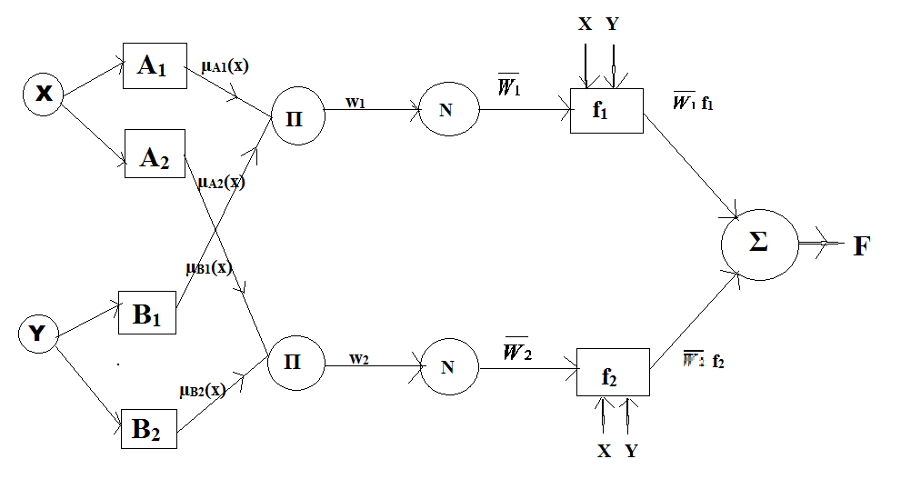
Fig 1: ANFIS architecture
Layer 1 is an adaptive layer that generates membership values of input variables. This Initial Fuzzy Inference System can be generated by Subtractive clustering or fuzzy clustering.
Layer 2 is a fixed layer that products the membership values from previous layer.
Layer 3 is a fixed layer that outputs the firing strength of each fuzzy rule.
Layer 4 is an adaptive layer that trains the consequent parameters using neural networks.
Layer 5 computes overall output as the sum of all incoming signals.
5. Test ANFIS with Test Data
The constructed model was tested using Testing data(1 fold of entire dataset). If the tested model not satisfying user threshold error rate, retrain the model using different data folds and test. This process was repeated until user specified epochs(iterations) or error tolerance value satisfied.

5. Experimentation &Results
We conducted experimentation of Software defect prediction datasets downloaded from NASA dataset repository. It contain 15 different datasets each with variant number of attributes. We obtained the strength of majority & minority classes for each dataset. These values are presented below.
Table 1: Description of SDP Datasets
Name of Dataset | No. of Negative Instances | No. of Positive Instances | Total No. of samples | Strength of Majority(-ve) class | Strength of Minority(+ve) class | No of attributes
ar1 | 112 | 9 | 121 | 93 | 7 | 30
ar3 | 55 | 8 | 63 | 87 | 13 | 30
ar4 | 80 | 27 | 107 | 75 | 25 | 30
ar5 | 28 | 8 | 36 | 78 | 22 | 30
ar6 | 86 | 15 | 101 | 85 | 15 | 30
cm1 | 285 | 42 | 327 | 87 | 13 | 38
jm1 | 8779 | 2106 | 10885 | 80 | 20 | 22
kc1 | 1783 | 326 | 2109 | 85 | 15 | 22
kc2 | 415 | 105 | 520 | 80 | 20 | 22
kc3 | 158 | 36 | 194 | 80 | 20 | 40
mc2 | 81 | 44 | 125 | 65 | 35 | 40
pc1 | 1032 | 77 | 1109 | 93 | 7 | 22
pc2 | 729 | 16 | 745 | 98 | 2 | 37
pc3 | 943 | 134 | 1077 | 86 | 14 | 38
pc4 | 1280 | 178 | 1458 | 88 | 12 | 38

6. Performance Evolution
We implemented Adaptive Neuro Fuzzy Inference system for Software Defect Prediction. These results shows better performance compared with other existing algorithms.

Table 2: Properties of Fuzzy Inference System
Type | sugeno
AND Method | prod
OR Method | probor
DefuzzMethod | wtaver
ImpMethod | prod
AggMethod | sum
Input: | [1x29 struct]
Output: | [1x1 struct]
Rule | [1x33 struct]

The model generates the two fuzzy rules with above properties using subtractive clustering method. The generated rules are presented below.
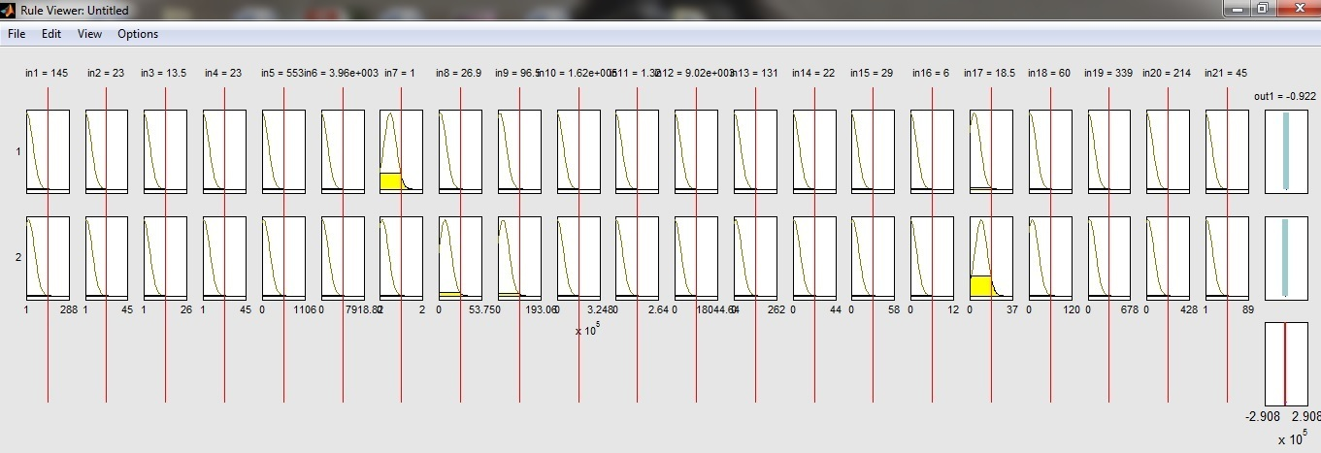
Fig 2: Fuzzy Inference System for SDP(kc1) Dataset
In FIS section, Initial Sugeno Fuzzy Inference system was derived by using subtractive clustering method. Subtractive clustering method takes four parameters Range of Influence(0.3), Squash factor(1.25) Accept ratio(0.5) & Reject Ratio(0.15). In training section, FIS was trained using ANFIS algorithm. In testing section, FIS was tested with unseen data. The Receiver Operating Characteristics(ROC) was plotted against true positive rate with false positive rate. AuC values are determined for each dataset of Software defect prediction.
The performance of imbalanced datasets is measured in terms of Area under ROC curve. ROC curves are generated by plotting True Positive rate against True Negative rate.

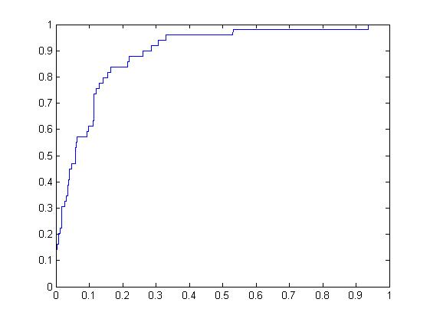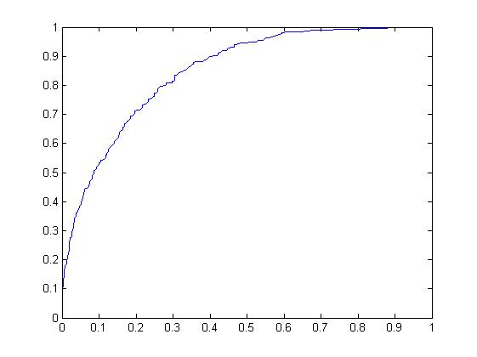
Fig 3: ROC Curve cm1 dataset Fig 4: ROC Curve kc1 dataset

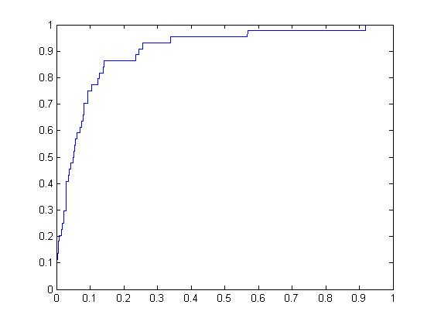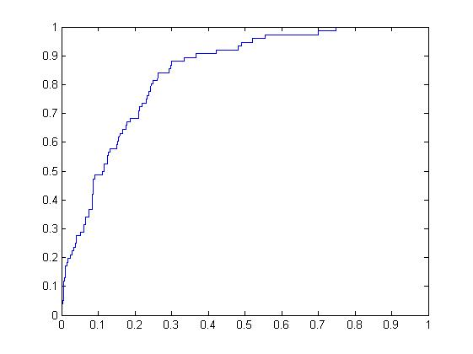
Fig 5: ROC Curve kc2 dataset Fig 6: ROC Curve pc1 dataset

7. Conclusion
In real world, the Data to be classified may be imbalanced in nature. Due to this imbalance nature, the classifier will bias towards majority class. To balance the classifier, we implemented Cost sensitive approach to Adaptive Neuro Fuzzy Inference System. We Tested this approach on Software Defect Prediction. The performance of the classifier was measured in terms of Area Under ROC Curves. These values for Software Defect Prediction were improved comparing to existing algorithms and presented in Results section.
References
[1] Haibo He, Edwardo a. Garcia, Learning from Imbalanced Data, IEEE Transactions on Knowledge and Data Engineering,21(9), Sept 2009.
[2] Mikel Galer, A Fernandez, Edurne B, Humberto B, IEEE Transactions on Systems, Man and Cybernetics, 2011

[3] Cristiano L, Antonio P, Novel Cost Sensitive Approach to Improve the Multilayer Perceptron Performance on Imbalanced Data, IEEE Transactions on Neural Networks & Learning Systems,24(6), June 2013.
[4]Shaoning Pang, Leizhu, Gang Chen et.al, Dynamic Class imbalance learning for incremental LPSVM, Neural Networks, Elsevier Publications, 44(2013), pp-87-100.
[5]Claudia Diamantini, Domenico Potena, Bayes Vector Quantizer for Class Imbalance Problem, IEEE Transactions on Knowledge and Data Engineering,21(5),May 2009.
[6] Rukshan Batuwita, Vasile Palade,FSVM-CIL: Fuzzy Support Vector Machines for Class Imbalance Learning, IEEE Transactions on Fuzzy Systems,18(3), June 2010.
[7] M Satya Srinivas, A Yesubabu, G Pradeepini, Cost sensitive class Imbalance Learning using ANFIS, Aust. J. Basic & Appl. Sci.,10(5),pp:144-149,2016.
[8] M Satya Srinivas, A Yesubabu, G Pradeepini, A Comparitive Study of Hybrid leaning over Back Propagation for Identifing Defective Prone Modules, International Journal of Soft Computing, Dec 2016.
[9] Agus Priyono,M Ridwan et.al, Generation of Fuzzy Rules with Subtractive Clustering, Jurnal Teknologi, 43(D),2005,pp:143-153
[10] Peng He, Bing Li, Xiao Liu,Jun Chen , Yutao Ma ,An empirical study on software defect prediction with a simplified metric set, Information & Software Technology,59(march 2015),pp:170-190

[11] Michael J. Siers, Md Zahidul Islam, Software defect prediction using a cost sensitive decision forest and voting, and a potential solution to the class imbalance problem, Information Systems,51( July 2015), pp:62-71.

[12] Omer Faruk Arar, Kusat Ayan, Software defect prediction using cost-sensitive neural network,Applied Soft Computing,33(August 2015),pp:263-277

[13] Issam H. Laradji, Mohammad Alshayeb, Lahouari Ghouti,Software defect prediction using ensemble learning on selected features, Information & Software Technology, 58(Febrauary 2015) pp:388-402

[14] Ezgi Erturk, Ebru Akcapinar Sezer, A comparison of some soft computing methods for software fault prediction, Expert Systems with Applications, 42(4), March 2015, pp:1872-1879.

[15]Harikesh Bahadur Yadav, Dilip Kumar Yadav, A fuzzy logic based approach for phase-wise software defects prediction using software metrics, Information & Software Technology,63(july 2015),pp:44-57

[16]Ezgi Erturk, Ebru Akcapinar sezer, Iterative software fault prediction with a hybrid approach, Applied Soft Computing, 49(December 2016),pp:1020-1033.

[17] K Subramanian, R Savitha, S Suresh, A complex-valued neuro-fuzzy inference system and its learning mechanism, Neurocomputing,123(2014)pp:110-120
[18]M Maruf Ozturk, Ahmet Zengin, HSDD: a Hybrid Sampling Strategy for Class Imbalance in Defect Prediction
Data Sets, Fifth International Conference on Future Generation Communication Technologies,2016.
[19] Shuo Wang, Xin Yao, Using Class Imbalance Learning for Software Defect Prediction, IEEE Transactions on Reliability,62(2), June 2013.
[20]Yang Y, M Mahfouf,G panoutsos,Q Zhang, Adaptive Neural-Fuzzy Inference System for
Classification of Rail Quality Data with Bootstrapping-Based Over-Sampling, 2011 IEEE International Conference on Fuzzy Systems,2011
[21] Romi Satria Wahno,A Systematic Literature Review of Software Defect Prediction: Research Trends, Datasets, Methods and Frameworks, Journal of Software Engineering,1(1),2015.
[22] Romi Satria Wahno ,Metaheuristic Optimization based Feature Selection for Software Defect Prediction, Journal of Software,2014.
[23] Satya Srinivas M, Dr A Yesubabu, Dr G Pradeepini,Feature Slection based Neural Networks for Software Defect Prediction, IOSR- Journal of Computer Engineering,4(2016).

